**Practical No. 01**

**Aim:-Write C# programs for understanding C# basics involving :**

1. **Variables and Data Types**
2. **Object based manipulation**
3. **Conditional logic**

**A) Variables and Data Types**

**1.Products of Given Number.**

using System;

using System.Collections.Generic;

using System.Linq;

using System.Text;

using System.Threading.Tasks;

namespace ConsoleApplication1

{

class Program

{

static void Main(string[] args)

{

int No1, No2, No3, No4, Product;

Console.WriteLine("Enter Four Numbers");

No1 = Convert.ToInt32(Console.ReadLine());

No2 = Convert.ToInt32(Console.ReadLine());

No3 = Convert.ToInt32(Console.ReadLine());

No4 = Convert.ToInt32(Console.ReadLine());

Product = No1 * No2 * No3 * No4;

Console.WriteLine("Product of Given Number Is:" +Product);

Console.ReadLine();

}

}

}

**O/P:-**

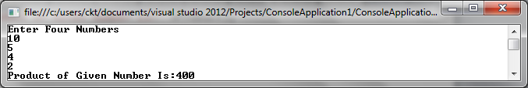

**B)** **Object-Based Manipulation**

**1)** **Program to demonstrate how to define the class and how to access members of class.**

using System;

using System.Collections.Generic;

using System.Linq;

using System.Text;

using System.Threading.Tasks;

namespace ConsoleApplication1

{

class Student

{

int RollNo;

string Name;

static void Main(string[] args)

{

Student s1=new Student();

s1.RollNo=1;

s1.Name="Ankur";

Console.WriteLine(s1.RollNo);

Console.WriteLine(s1.Name);

Console.ReadLine();

}

}

}

**O/P:-**



**2) Programs to demonstrate the class where we are having main() method in another class.**

using System;

using System.Collections.Generic;

using System.Linq;

using System.Text;

using System.Threading.Tasks;

namespace ConsoleApplication1

{

public class Student

{

public int RollNo;

public string Name;

}

class TestStudent

{

static void Main(string[] args)

{

Student s1=new Student();

s1.RollNo=1;

s1.Name="Ankur";

Console.WriteLine(s1.RollNo);

Console.WriteLine(s1.Name);

Console.ReadLine();

}

}

}

**O/P:-**



**C)Conditional Logic**

**1)Whether to check given number is prime or not.**

using System;

using System.Collections.Generic;

using System.Linq;

using System.Text;

using System.Threading.Tasks;

namespace ConsoleApplication1

{

class Program

{

static void Main(string[] args)

{

int p = 0;

Console.WriteLine("Enter Number");

int n = Int16.Parse(Console.ReadLine());

for (int i = 1; i <= n; i++)

{

if (n % i == 0)

{

p++;

}

}

if (p == 2)

{

Console.WriteLine("Entered Number is Prime");

}

else

{

Console.WriteLine("Entered Number is not Prime");

}

Console.ReadLine();

}

}

}

**O/P:-**

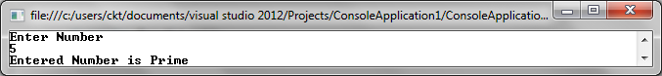

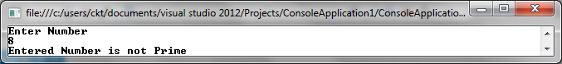

**Practical no:-02**

**Aim:-Write C# programs for understanding C# basics involving :**

**a.Loops b. Methods**

**A)Loops**

**1)Fibonacci Series.**

using System;

using System.Collections.Generic;

using System.Linq;

using System.Text;

using System.Threading.Tasks;

namespace ConsoleApplication1

{

class Program

{

static void Main(string[] args)

{

int a = 0;

int b = 1;

int c;

for (int i = 1; i <= 10; i++)

{

c = a + b;

a = b;

b = c;

Console.Write(c + "\t");

}

Console.ReadLine();

}

}

}

**O/P:-** 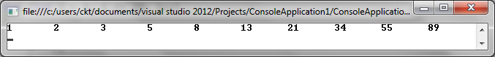

**B)Methods**

**1)Program to demonstrate user defined function.**

using System;

using System.Collections.Generic;

using System.Linq;

using System.Text;

using System.Threading.Tasks;

namespace ConsoleApplication1

{

class FactorialExample

{

public int factorial(int n)

{

int result;

if (n == 1)

{

return 1;

}

else

{

result = factorial(n - 1) * n;

return result;

}

}

static void Main(string[] args)

{

FactorialExample f = new FactorialExample();

int fact = f.factorial(5);

Console.WriteLine("Factorial of Number is:" + fact);

Console.ReadLine();

}

}

}

**O/P:-** 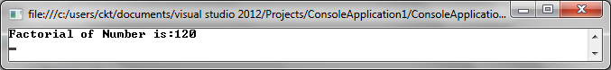

**Practical No:-03**

**Aim:-Write C# programs for Object oriented concepts of C# such as:**

**a. Program using classes**

**b. Constructor and Function Overloading**

**A) Program using classes**

using System;

using System.Collections.Generic;

using System.Linq;

using System.Text;

using System.Threading.Tasks;

namespace ConsoleApplication2

{

class FunctionOverloading

{

static void area(int a, int b)

{

Console.WriteLine("Area of Rectangle is:" + (a * b));

}

static void area(int x)

{

Console.WriteLine("Area of Square is:" + (x * x));

}

static void area(int i, int j,int k)

{

Console.WriteLine("Area of Triangle is:" + (i*j*k));

}

static void Main(string[] args)

{

area(23);

area(12, 45);

area(12, 23, 14);

Console.ReadLine();

}

}

}

**O/P:-**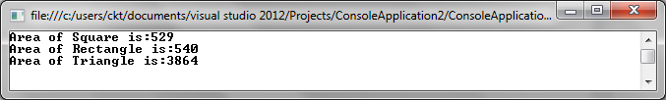

**B) Constructor and Function Overloading**

using System;

using System.Collections.Generic;

using System.Linq;

using System.Text;

using System.Threading.Tasks;

namespace ConsoleApplication2

{

class Construct

{

public Construct (int a, int b)

{

Console.WriteLine("Area of Rectangle is:" + (a * b));

}

public Construct (int x)

{

Console.WriteLine("Area of Square is:" + (x * x));

}

public Construct (int i, int j,int k)

{

Console.WriteLine("Area of Triangle is:" + (i*j*k));

}

static void Main(string[] args)

{

Construct c1 = new Construct(23);

Construct c2 = new Construct(12,45);

Construct c3 = new Construct(12,23,14);

Console.ReadLine();

}

}

}

**O/P:-**

**Practical no:-04**

**Aim:-Write C# programs for object oriented concepts of C# such as :**

**a)Inheritance b)namespaces**

1. **Inheritance**

using System;

using System.Collections.Generic;

using System.Linq;

using System.Text;

using System.Threading.Tasks;

namespace ConsoleApplication2

{

class student

{

public int hin,mar,eng,sports,tot,avg;

public void getmarks()

{

Console.Write("Enter marks of three subjects:");

hin=Convert.ToInt32(Console.ReadLine());

mar=Convert.ToInt32(Console.ReadLine());

eng=Convert.ToInt32(Console.ReadLine());

}

}

class sportsclass : student

{

public void getsports()

{

Console.Write("Enter marks of sports:");

hin = Convert.ToInt32(Console.ReadLine());

}

}

class result : sportsclass

{

public void cal()

{

tot = hin + mar + eng + sports;

avg = tot / 3;

Console.WriteLine("Total marks:" + tot);

Console.WriteLine("Average:" + avg);

}

}

class D

{

public static void Main(String[]args)

{

result r = new result();

r.getmarks();

r.getsports();

r.cal();

Console.ReadLine();

}

}

}

**O/P:-**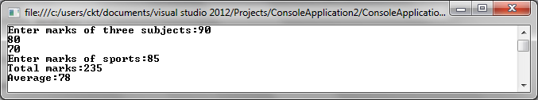

1. **Namespaces**

using System;

using System.Collections.Generic;

using System.Linq;

using System.Text;

using System.Threading.Tasks;

using First;

using Second;

namespace First

{

class NamespaceDemo1

{

public void sayHi()

{

Console.WriteLine("Hi First Namespace");

}

}

}

namespace Second

{

class NamespaceDemo2

{

public void saywelcome()

{

Console.WriteLine("Welcome Second Namespace");

}

}

}

class TestNamespace

{

static void Main(string[] args)

{

NamespaceDemo1 h1 = new NamespaceDemo1();

NamespaceDemo2 h2 = new NamespaceDemo2();

h1.sayHi();

h2.saywelcome();

Console.ReadLine();

}

}

**O/P:-**



**Practical No:-05**

**Aim:- Design ASP.NET Pages with :**

**a) Server controls.**

**b) Web controls and demonstrate the use of AutoPostBack**

**INPUT (HTML File)**

**#webform1.aspx**

<%@ Page Language="C#" AutoEventWireup="true" CodeBehind="WebForm1.aspx.cs" Inherits="WebApplication3.WebForm1" %>

<!DOCTYPE html>

<html xmlns="http://www.w3.org/1999/xhtml">

<head runat="server"><title></title></head>

<body>

<form id="form1" runat="server">

<div><asp:Label ID="Label1" runat="server" Text="Name"></asp:Label>

<asp:TextBox ID="TextBox1" runat="server" Height="22px" OnTextChanged="TextBox1_TextChanged" Width="128px"></asp:TextBox></div>

&nbsp;<p>

<asp:Label ID="Label2" runat="server" Text="Address"></asp:Label>

<asp:TextBox ID="TextBox2" runat="server" OnTextChanged="TextBox2_TextChanged" style="margin-bottom: 0px"></asp:TextBox>

</p><p>

<asp:Label ID="Label4" runat="server" Text="Country"></asp:Label>

<asp:TextBox ID="TextBox3" runat="server"></asp:TextBox>

</p><p>

<asp:Label ID="Label3" runat="server" Text="Email"></asp:Label>

<asp:TextBox ID="TextBox4" runat="server" OnTextChanged="TextBox4_TextChanged"></asp:TextBox>

</p><p>

<asp:Label ID="Label5" runat="server" Text="Gender"></asp:Label>

</p>

h<asp:RadioButtonList ID="RadioButtonList1" runat="server" Height="51px" OnSelectedIndexChanged="RadioButtonList1_SelectedIndexChanged" Width="152px">

<asp:ListItem>Female</asp:ListItem>

<asp:ListItem>Male</asp:ListItem>

</asp:RadioButtonList><br />

<asp:Label ID="Label6" runat="server" Text="Hobbies"></asp:Label>

<asp:CheckBoxList ID="CheckBoxList1" runat="server" OnSelectedIndexChanged="CheckBoxList1_SelectedIndexChanged">

<asp:ListItem>Reading</asp:ListItem>

<asp:ListItem>Writing</asp:ListItem>

<asp:ListItem>Gaming</asp:ListItem>

</asp:CheckBoxList>

<asp:Label ID="Label7" runat="server" Text="Birth Date"></asp:Label>

<asp:Label ID="Label8" runat="server" Text="Label"></asp:Label><br />

<asp:Calendar ID="Calendar1" runat="server" OnSelectionChanged="Calendar1_SelectionChanged"></asp:Calendar>

<asp:Button ID="Button1" runat="server" Text="Submit" OnClick="Button1_Click" /><p>

&nbsp;</p>

</form></body></html>

**Input (ASPX.cs) :**

**#Webform1.aspx.cs**

using System;

using System.Collections.Generic;

using System.Linq;

using System.Web;

using System.Web.UI;

using System.Web.UI.WebControls;

namespace WebApplication1

{

public partial class WebForm1 : System.Web.UI.Page

{

protected void Page_Load(object sender, EventArgs e)

{

}

protected void TextBox1_TextChanged(object sender, EventArgs e)

{

}

protected void Calendar1_SelectionChanged(object sender, EventArgs e)

{

Label1.Text = Calendar1.SelectedDate.ToShortDateString();

}

protected void Button1_Click(object sender,EventArgs e)

{

Response.Redirect("WebForm1.aspx");

}

}

}

**O/P:-**

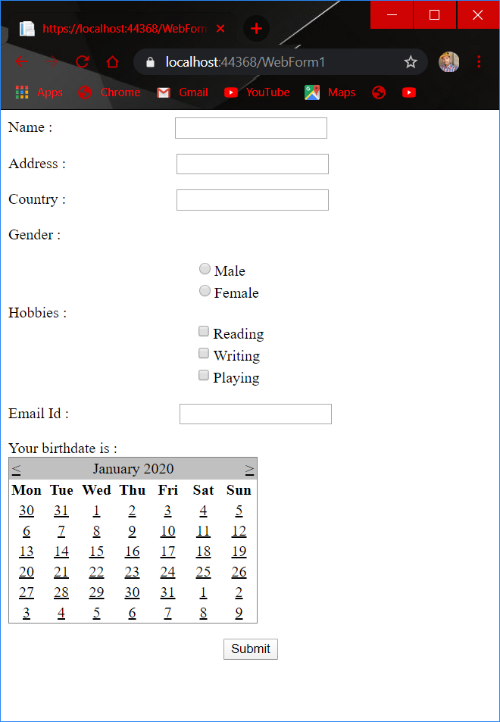

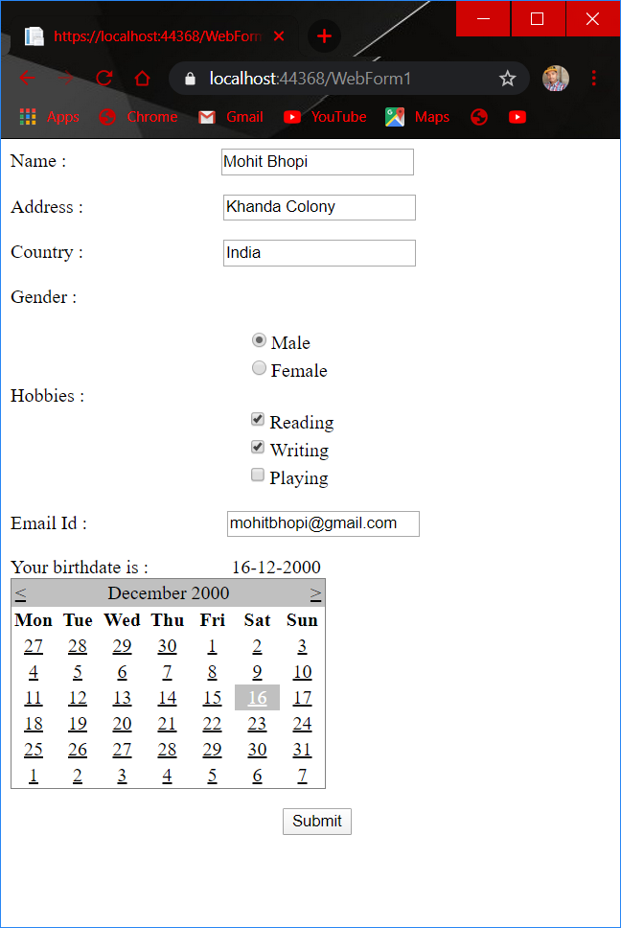

**B) Web controls and demonstrate the use of AutoPostBack**

**Program:**

**INPUT (HTML File)**

**webform1.aspx**

<%@PageLanguage="C#"AutoEventWireup="true"CodeBehind="WebForm1.aspx.cs"Inherits="WebApplication18.WebForm1"%>

<!DOCTYPEhtml>

<scriptrunat="server">

protectedvoid DropDownList1_SelectedIndexChanged(object sender, System.EventArgs e)

{

Label1.Text = "Your favourite colour is: " + DropDownList1.SelectedItem.Text;

}

</script>

<htmlxmlns="http://www.w3.org/1999/xhtml">

<headid="Head1"runat="server">

<title>How to use DropDownListAutoPostBack feature</title>

</head>

<body>

<formid="form1"runat="server">

<div>

<h2style="color:Navy">DropDownList: AutoPostBack</h2>

<asp:Label

ID="Label1"

runat="server"

Font-Bold="true"

ForeColor="Purple"

Font-Size="Large"

>

</asp:Label>

<br/><br/>

<asp:Label

ID="Label2"

runat="server"

Font-Bold="true"

ForeColor="OrangeRed"

Text="Favourite colour"

>

</asp:Label>

<asp:DropDownList

ID="DropDownList1"

runat="server"

AutoPostBack="true"

OnSelectedIndexChanged="DropDownList1_SelectedIndexChanged"style="margin-left: 13px"

>

<asp:ListItem>pink</asp:ListItem>

<asp:ListItem>red</asp:ListItem>

<asp:ListItem>blue</asp:ListItem>

<asp:ListItem>green</asp:ListItem>

<asp:ListItem>purple</asp:ListItem>

</asp:DropDownList>

</div>

</form>

</body>

</html>

**INPUT(ASPX c.s)**

using System;

usingSystem.Collections.Generic;

usingSystem.Linq;

usingSystem.Web;

usingSystem.Web.UI;

usingSystem.Web.UI.WebControls;

namespace WebApplication18

{

publicpartialclassWebForm1 : System.Web.UI.Page

{

protectedvoidPage_Load(object sender, EventArgs e)

{

}

protectedvoid DropDownList1_SelectedIndexChanged(object sender, EventArgs e)

{

}

}

}

**O/P:-**

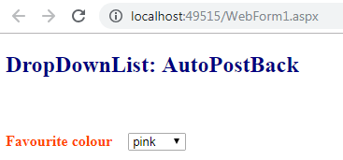

**After selecting colour**

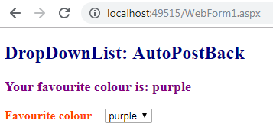

**Practical No. 06**

**Aim : Design ASP.NET Pages with Rich Controls.**

**1. Rich Controls (Ad Rotator)**

**Program:**

**INPUT (HTML File)**

webform1.aspx

<%@ Page Language="C#" AutoEventWireup="true" CodeBehind="WebForm1.aspx.cs" Inherits="WebApplication11.WebForm1" %>

<!DOCTYPE html>

<html xmlns="http://www.w3.org/1999/xhtml">

<head runat="server">

<title></title>

</head>

<body>

<form id="form1" runat="server">

<div>

</div>

<asp:AdRotator ID="AdRotator1" AdvertisementFile="~/XMLFile1.xml" runat="server" OnAdCreated="AdRotator1_AdCreated" />

</form>

</body>

</html>

**INPUT(ASPX c.s)**

using System;

using System.Collections.Generic;

using System.Linq;

using System.Web;

using System.Web.UI;

using System.Web.UI.WebControls;

namespace WebApplication11

{

public partial class WebForm1 : System.Web.UI.Page

{

protected void Page_Load(object sender, EventArgs e)

{

}

protected void AdRotator1_AdCreated(object sender, AdCreatedEventArgs e)

{

}

}

}

**INPUT(XMLfile1.xml)**

<?xml version="1.0" encoding="utf-8" ?>

<Advertisements>

<Ad>

<ImageUrl>~\image\java logo.jpg</ImageUrl>

<NavigateUrl>https://www.wikipedia.org/</NavigateUrl>

<AlternateText>page1</AlternateText>

<KeyWord>B</KeyWord>

<Impressions>Technology</Impressions>

<caption>this is a caption for ad#1</caption>

</Ad>

<Ad>

<ImageUrl>~\image\oracle.logo.png</ImageUrl>

<NavigateUrl>Ad2.aspx</NavigateUrl>

<AlternateText>page2</AlternateText>

<KeyWord>B</KeyWord>

<Impressions>Website</Impressions>

<caption>this is a caption for ad#2</caption>

</Ad>

</Advertisements>

**AD@.aspx**

<%@ Page Language="C#" AutoEventWireup="true" CodeBehind="Ad2.aspx.cs" Inherits="WebApplication11.Ad2" %>

<!DOCTYPE html>

<html xmlns="http://www.w3.org/1999/xhtml">

<head runat="server">

<title></title>

</head>

<body>

<form id="form1" runat="server">

<div>

<h1>Oracle is one of the largest vendors in the enterprise IT market and

the shorthand name of its flagship product,

a relational database management system (RDBMS) that's formally called Oracle Database</h1>

</div>

</form>

</body></html>

**O/P :-**

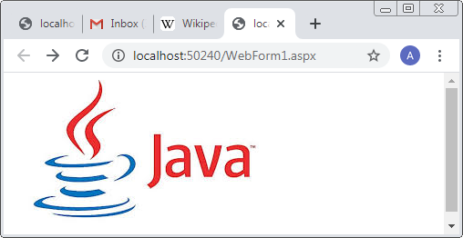

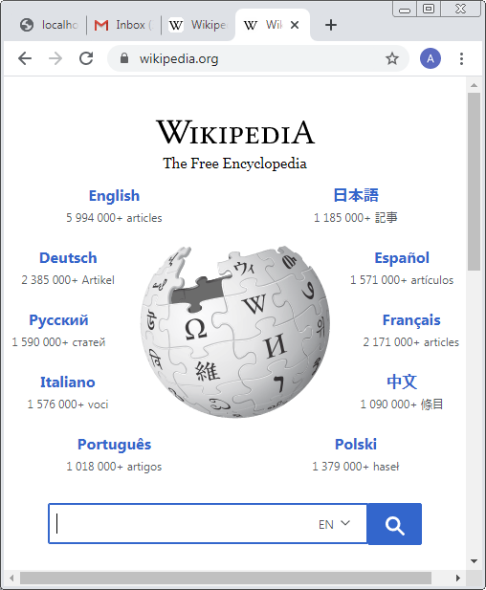

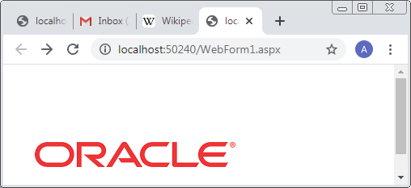

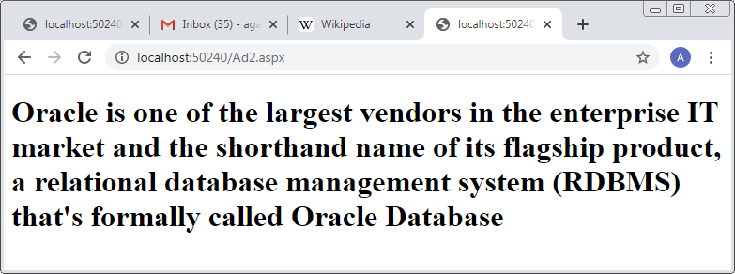

**Practical No-:07**

**Aim:- Design ASP.NET pages for state management using :**

**a. Cookies b. Session state c. Application State**

**1)Cookies**

**Input (html file):**

**WebForm1.aspx**

<%@ Page Language="C#" AutoEventWireup="true" CodeBehind="WebForm1.aspx.cs" Inherits="WebApplication4.WebForm1" %>

<!DOCTYPE html>

<html xmlns="http://www.w3.org/1999/xhtml">

<head runat="server">

<title></title>

</head>

<body runat="server" id="BodyTag">

<form id="form1" runat="server">

<div>

<center>

<asp:DropDownList ID="DropDownList1" runat="server" AutoPostBack="true" OnSelectedIndexChanged="DropDownList1_SelectedIndexChanged">

<asp:ListItem Value="White" Selected="True">Selected Color....</asp:ListItem>

<asp:ListItem>Red</asp:ListItem>

<asp:ListItem>Yellow</asp:ListItem>

<asp:ListItem>Green</asp:ListItem>

<asp:ListItem>Blue</asp:ListItem>

<asp:ListItem>Black</asp:ListItem>

</asp:DropDownList>

</center>

</div>

</form>

</body>

</html>

**Input (html file):**

**WebForm1.aspx.cs**

using System;

using System.Collections.Generic;

using System.Linq;

using System.Web;

using System.Web.UI;

using System.Web.UI.WebControls;

namespace WebApplication4

{

public partial class WebForm1 : System.Web.UI.Page

{

protected void Page_Load(object sender, EventArgs e)

{

if (Request.Cookies["BackgroundColor"] != null)

{

DropDownList1.SelectedValue = Request.Cookies["BackgroundColor"].Value;

BodyTag.Style["background-color"] = DropDownList1.SelectedValue;

}

}

protected void DropDownList1_SelectedIndexChanged(object sender, EventArgs e)

{

BodyTag.Style["background-color"] = DropDownList1.SelectedValue;

HttpCookie cookie = new HttpCookie("BackgroundColor");

cookie.Value = DropDownList1.SelectedValue;

cookie.Expires = DateTime.Now.AddSeconds(5);

Response.SetCookie(cookie);

}

}

}

**O/P:-**

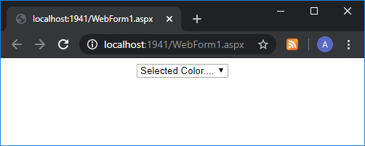

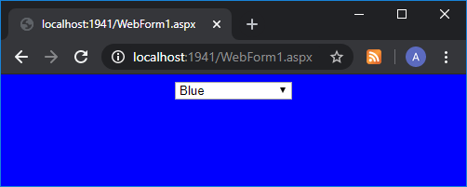

**B) Session State**

**Input(WebForm1.aspx)**

<%@ Page Language="C#" AutoEventWireup="true" CodeBehind="WebForm1.aspx.cs" Inherits="WebApplication4.WebForm1" %>

<!DOCTYPE html>

<html xmlns="http://www.w3.org/1999/xhtml">

<head runat="server">

<title></title>

</head>

<body runat="server" id="BodyTag">

<form id="form1" runat="server">

<div>

<center>

<asp:DropDownList ID="DropDownList1" runat="server" AutoPostBack="true" OnSelectedIndexChanged="DropDownList1_SelectedIndexChanged">

<asp:ListItem Value="White" Selected="True">Selected Color....</asp:ListItem>

<asp:ListItem>Red</asp:ListItem>

<asp:ListItem>Yellow</asp:ListItem>

<asp:ListItem>Green</asp:ListItem>

<asp:ListItem>Blue</asp:ListItem>

<asp:ListItem>Black</asp:ListItem>

</asp:DropDownList>

</center>

</div>

</form>

</body>

</html>

**Aspx.cs**

using System;

using System.Collections.Generic;

using System.Linq;

using System.Web;

using System.Web.UI;

using System.Web.UI.WebControls;

namespace WebApplication4

{

public partial class WebForm1 : System.Web.UI.Page

{

protected void Page_Load(object sender, EventArgs e)

{

if (Session["BackgroundColor"] != null)

{

DropDownList1.SelectedValue = Session["BackgroundColor"].ToString();

BodyTag.Style["Background-Color"] = DropDownList1.SelectedValue;

}

}

protected void DropDownList1_SelectedIndexChanged(object sender, EventArgs e)

{

BodyTag.Style["Background-Color"] = DropDownList1.SelectedValue;

Session["BackgroundColor"] = DropDownList1.SelectedValue;

}

}

}

**O/P:-**

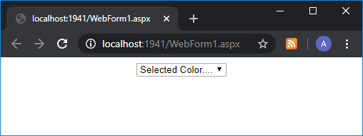

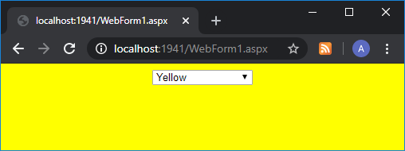

**C) Application State**

**WebForm1.aspx**

<%@ Page Language="C#" AutoEventWireup="true" CodeBehind="WebForm1.aspx.cs" Inherits="WebApplication4.WebForm1" %>

<!DOCTYPE html>

<html xmlns="http://www.w3.org/1999/xhtml">

<head runat="server">

<title></title>

</head>

<body>

<form id="form1" runat="server">

<h2 style="color:teal">ASP.NET application Status Example</h2>

<asp:Label ID="Label1" runat="server" Text="Label"></asp:Label>

<br /><br /><br /><br /><br />

<asp:Button ID="Button1" runat="server" Text="Show Button CLick Status" OnClick="Button_Click" Font-Bold="true" />

</form>

</body>

</html>

**Aspx.cs**

using System;

using System.Collections.Generic;

using System.Linq;

using System.Web;

using System.Web.UI;

using System.Web.UI.WebControls;

namespace WebApplication4

{

public partial class WebForm1 : System.Web.UI.Page

{

protected void Page_Load(object sender, EventArgs e)

{

}

protected void Button_Click(object sender, EventArgs e)

{

int counter = 0;

if (Application["ButtonClickCounter"] != null)

{

counter = (int)Application["ButtonClickCounter"];

}

counter++;

Application["ButtonClickCounter"] = counter;

Label1.Text = "Button Clicked:-" + counter.ToString() + "Times";

}

}

}

**O/P:-**

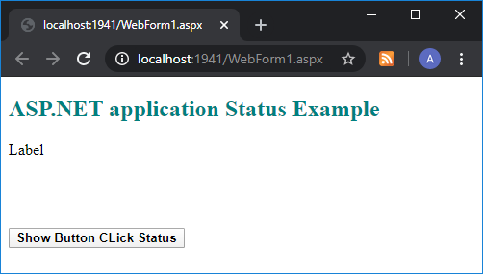

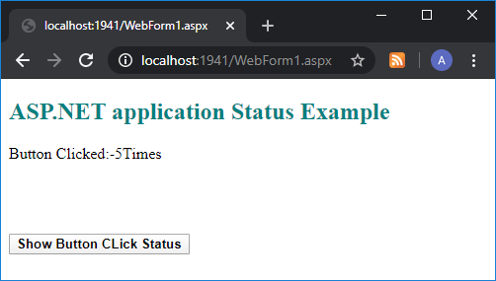

**Practical No:-08**

**Aim:-Design ASP.NET page and perform validation using various Validation Controls**

**WebForm1.aspx**

<%@ Page Language="C#" AutoEventWireup="true" CodeBehind="WebForm1.aspx.cs" Inherits="WebApplication5.WebForm1" %>

<!DOCTYPE html>

<html xmlns="http://www.w3.org/1999/xhtml">

<head runat="server">

<title></title>

</head>

<body>

<form id="form1" runat="server">

<h1>Department of Computer Science</h1>

<div style="height: 493px">

<asp:Label ID="Label1" runat="server" Text="User ID"></asp:Label> &nbsp;&nbsp;&nbsp;&nbsp;&nbsp;&nbsp;&nbsp;&nbsp;&nbsp;&nbsp;&nbsp;&nbsp;&nbsp;&nbsp;&nbsp;&nbsp;&nbsp;&nbsp;&nbsp;&nbsp;&nbsp;&nbsp;&nbsp;&nbsp;&nbsp;&nbsp;&nbsp;&nbsp;

<asp:TextBox ID="TextBox1" runat="server" OnTextChanged="TextBox1_TextChanged" style="margin-left: 52px"></asp:TextBox>

<asp:RequiredFieldValidator ID="RequiredFieldValidator1" runat="server" ControlToValidate="TextBox1" ErrorMessage="please enter User ID"></asp:RequiredFieldValidator>

<br /><br />

<asp:Label ID="Label2" runat="server" Text="PASSWORD"></asp:Label>

&nbsp;&nbsp;&nbsp;&nbsp;&nbsp;&nbsp;&nbsp;&nbsp;&nbsp;&nbsp;&nbsp;&nbsp;&nbsp;&nbsp;&nbsp;&nbsp;&nbsp;&nbsp;&nbsp;&nbsp;&nbsp;&nbsp;&nbsp;&nbsp;&nbsp;&nbsp;&nbsp;&nbsp;&nbsp;&nbsp;&nbsp;&nbsp;

<asp:TextBox ID="TextBox2" runat="server"></asp:TextBox>

<asp:RequiredFieldValidator ID="RequiredFieldValidator2" runat="server" ControlToValidate="TextBox2" ErrorMessage="please enter password"></asp:RequiredFieldValidator>

<br />

<br />

<asp:Label ID="Label3" runat="server" Text="CONFIRM PASSWORD"></asp:Label>

&nbsp;&nbsp;&nbsp;&nbsp;&nbsp;&nbsp;&nbsp;&nbsp; &nbsp;&nbsp;&nbsp;

<asp:TextBox ID="TextBox3" runat="server"></asp:TextBox>

<asp:RequiredFieldValidator ID="RequiredFieldValidator3" runat="server" ControlToValidate="TextBox3" ErrorMessage="confirm your password"></asp:RequiredFieldValidator>

<asp:CompareValidator ID="CompareValidator1" runat="server" ControlToCompare="TextBox2" ControlToValidate="TextBox3" ErrorMessage=" password is not same"></asp:CompareValidator>

<br /><br />

<asp:Label ID="Label4" runat="server" Text="Age"></asp:Label>

&nbsp;&nbsp;&nbsp;&nbsp;&nbsp;&nbsp;&nbsp;&nbsp;&nbsp;&nbsp;&nbsp;&nbsp;&nbsp;&nbsp;&nbsp;&nbsp;&nbsp;&nbsp;&nbsp;&nbsp;&nbsp;&nbsp;&nbsp;&nbsp;&nbsp;&nbsp;&nbsp;&nbsp;&nbsp;&nbsp;&nbsp;&nbsp;&nbsp;&nbsp;&nbsp;&nbsp;&nbsp;&nbsp;&nbsp;&nbsp;&nbsp;&nbsp;&nbsp;&nbsp;&nbsp;&nbsp;

<asp:TextBox ID="TextBox4" runat="server"></asp:TextBox>

<asp:RangeValidator ID="RangeValidator1" runat="server" MaximumValue="30" MinimumValue="15" ControlToValidate="TextBox4" ErrorMessage="Your age must match requirenment" Type="Integer" SetFocusOnError="true"></asp:RangeValidator>

<br /><br />

<asp:Label ID="Label5" runat="server" Text="E-MAIL"></asp:Label>

&nbsp;&nbsp;&nbsp;&nbsp;&nbsp;&nbsp;&nbsp;&nbsp;&nbsp;&nbsp;&nbsp;&nbsp;&nbsp;&nbsp;&nbsp;&nbsp;&nbsp;&nbsp;&nbsp;&nbsp;&nbsp;&nbsp;&nbsp;&nbsp;&nbsp;&nbsp;&nbsp;&nbsp;&nbsp;&nbsp;&nbsp;&nbsp;&nbsp;&nbsp;&nbsp;&nbsp;&nbsp;&nbsp;&nbsp;

<asp:TextBox ID="TextBox5" runat="server"></asp:TextBox>

<asp:RequiredFieldValidator ID="RequiredFieldValidator4" runat="server" ControlToValidate="TextBox5" ErrorMessage="Enter valid E-MAIL format"></asp:RequiredFieldValidator>

<asp:RegularExpressionValidator ID="RegularExpressionValidator1" runat="server" ControlToValidate="TextBox5" ErrorMessage="Enter your E-MAIL" ValidationExpression="\w+([-+.']\w+)*@\w+([-.]\w+)*\.\w+([-.]\w+)*"></asp:RegularExpressionValidator>

<br /><br />

&nbsp;&nbsp;&nbsp;&nbsp;&nbsp;&nbsp;&nbsp;&nbsp;&nbsp;&nbsp;&nbsp;&nbsp;&nbsp;&nbsp;&nbsp;&nbsp;&nbsp;&nbsp;&nbsp;&nbsp;&nbsp;&nbsp;&nbsp;&nbsp;&nbsp;&nbsp;&nbsp;

<asp:Button ID="Button1" runat="server" Text="SUBMIT" OnClick="Button1_Click" />

<asp:ValidationSummary ID="ValidationSummary1" runat="server" />

</div></form></body>

</html>

**WebForm2.aspx**

<%@ Page Language="C#" AutoEventWireup="true" CodeBehind="WebForm2.aspx.cs" Inherits="WebApplication5.WebForm2" %>

<!DOCTYPE html>

<html xmlns="http://www.w3.org/1999/xhtml">

<head runat="server"><title></title></head>

<body>

<form id="form1" runat="server">

<div><marquee>

<h1> WELCOME TO COMPUTER SCIENCE DEPARTMENT</h1></marquee>

</div></form></body>

</html>

**WebForm1.aspx.cs**

using System;

using System.Collections.Generic;

using System.Linq;

using System.Web;

using System.Web.UI;

using System.Web.UI.WebControls;

namespace WebApplication5

{

public partial class WebForm1 : System.Web.UI.Page

{

protected void Page_Load(object sender, EventArgs e)

{}

protected void TextBox1_TextChanged(object sender, EventArgs e)

{}

protected void Button1_Click(object sender, EventArgs e)

{

Response.Redirect("WebForm2.aspx");

}

}

}

**Web.config**

<?xml version="1.0"?>

<!--

For more information on how to configure your ASP.NET application, please visit

http://go.microsoft.com/fwlink/?LinkId=169433

-->

<configuration>

<system.web>

<compilation debug="true" targetFramework="4.5" />

<httpRuntime targetFramework="4.5" />

</system.web>

<appSettings>

<add key="ValidationSettings:UnobtrusiveValidationMode" value="None"/>

</appSettings>

</configuration>

**O/P:-**

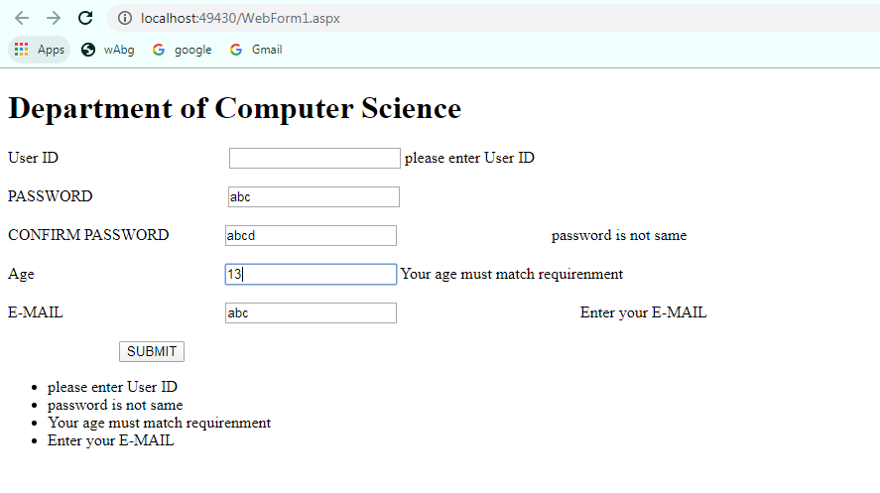

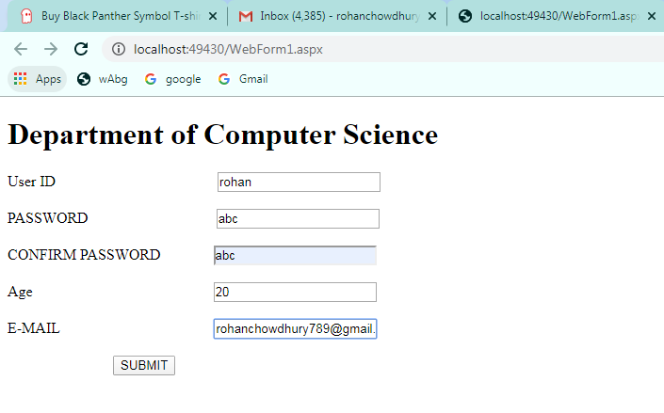

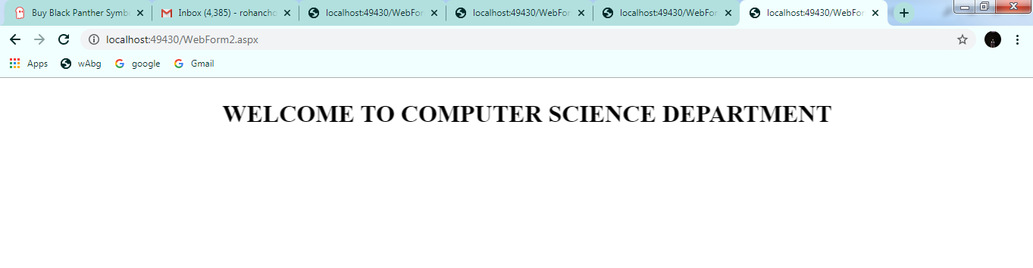

**Practical No. 09**

**Aim : Design an ASP.NET master web page and use it other (at least 2-3) content pages.**

**Site1.Master**

<%@ Master Language="C#" AutoEventWireup="true" CodeBehind="Site1.master.cs"

Inherits="Master.Site1" %>

<!DOCTYPE html>

<html xmlns="http://www.w3.org/1999/xhtml">

<head runat="server">

<title></title>

<asp:ContentPlaceHolder ID="head" runat="server">

</asp:ContentPlaceHolder>

</head>

<body>

<form id="form1" runat="server">

<div>

<asp:Table ID="Table1" runat="server" Height="120px" Width="570px">

<asp:TableRow ID="TableRow1" runat="server">

<asp:TableCell ID="TableCell1" runat="server">

<asp:Image ID="Image1" runat="server" ImageUrl="~/images/i.jpg"

Width="170" Height="100" /></asp:TableCell>

<asp:TableCell ID="TableCell2" runat="server">

<asp:Label ID="Label1" runat="server" Text="Ice Cream Parlor "

Font-Bold="False" Font-Size="30px" ForeColor="Red" Font-Names="Algerian"></asp:Label><br

/><br />

<asp:LinkButton ID="LinkButton1" runat="server"

ForeColor="#660066" Font-Names="Times New Roman" Font-Size="20px"

PostBackUrl="~/WebForm1.aspx">Home</asp:LinkButton>

&nbsp;&nbsp;&nbsp;&nbsp;&nbsp;

<asp:LinkButton ID="LinkButton2" runat="server"

ForeColor="#660066" Font-Names="Times New Roman" Font-Size="20px"

PostBackUrl="~/WebForm2.aspx">About Us</asp:LinkButton>

</asp:TableCell>

</asp:TableRow>

</asp:Table>

<asp:ContentPlaceHolder ID="ContentPlaceHolder1" runat="server">

</asp:ContentPlaceHolder>

</div>

</form>

</body>

</html>

**WebForm1.aspx**

<%@ Page Title="" Language="C#" MasterPageFile="~/Site1.Master" AutoEventWireup="true"

CodeBehind="WebForm1.aspx.cs" Inherits="Master.WebForm1" %>

<asp:Content ID="Content1" ContentPlaceHolderID="head" runat="server">

</asp:Content>

<asp:Content ID="Content2" ContentPlaceHolderID="ContentPlaceHolder1" runat="server">

<asp:Table ID="Table1" runat="server" Height="160px" Width="570px">

<asp:TableRow ID="TableRow1" runat="server">

<asp:TableCell ID="TableCell1" runat="server">

<asp:Label ID="Labal1" runat="server" Text="Pista " Font-Size="20px"

ForeColor="BlueViolet" Font-Bold="True"></asp:Label>

</asp:TableCell>

<asp:TableCell ID="TableCell2" runat="server">

<asp:Label ID="Label2" runat="server" Text="Chocolate " Font-Bold="True"

Font-Size="20px" ForeColor="BlueViolet"></asp:Label>

</asp:TableCell>

</asp:TableRow>

<asp:TableRow ID="TableRow2" runat="server">

<asp:TableCell ID="TableCell3" runat="server">

<asp:Image ID="Image1" runat="server" ImageUrl="~/images/pista.jpg"

Width="150" Height="100" />

</asp:TableCell>

<asp:TableCell ID="TableCell4" runat="server">

<asp:Image ID="Image2" runat="server" ImageUrl="~/images/choclate.jpg"

Width="150" Height="100" />

</asp:TableCell>

</asp:TableRow>

<asp:TableRow ID="TableRow4" runat="server">

<asp:TableCell ID="TableCell5" runat="server">

<asp:Label ID="Label1" runat="server" Text="Venilla" Font-Size="20px"

ForeColor="BlueViolet" Font-Bold="True"></asp:Label>

</asp:TableCell>

<asp:TableCell ID="TableCell6" runat="server">

<asp:Label ID="Label3" runat="server" Text="Strawberry " Font-

Bold="True" Font-Size="20px" ForeColor="BlueViolet"></asp:Label>

</asp:TableCell>

</asp:TableRow>

<asp:TableRow ID="TableRow5" runat="server">

<asp:TableCell ID="TableCell7" runat="server">

<asp:Image ID="Image3" runat="server" ImageUrl="~/images/venilla.jpg"

Width="150" Height="100" />

</asp:TableCell>

<asp:TableCell ID="TableCell8" runat="server">

<asp:Image ID="Image4" runat="server" ImageUrl="~/images/straw.jpg"

Width="150" Height="100" />

</asp:TableCell>

</asp:TableRow>

</asp:Table>

</asp:Content>

**WebForm2.aspx**

<%@ Page Title="" Language="C#" MasterPageFile="~/Site1.Master" AutoEventWireup="true"

CodeBehind="WebForm2.aspx.cs" Inherits="Master.WebForm2" %>

<asp:Content ID="Content1" ContentPlaceHolderID="head" runat="server">

</asp:Content>

<asp:Content ID="Content2" ContentPlaceHolderID="ContentPlaceHolder1" runat="server">

<asp:Label ID="Labal1" runat="server" Text="Ice Cream Flavour " Font-Size="20px"

ForeColor="BlueViolet" Font-Bold="True"></asp:Label>

<br /><br />

<b>This is a list of notable ice cream flavors. <br />

Ice cream is a frozen dessert usually made from dairy products, such as milk and

cream and often combined with fruits or other ingredients and flavors.

<br /> Most varieties contain sugar, although some are made with other

sweeteners.</b>

</asp:Content>

**O/P:-**

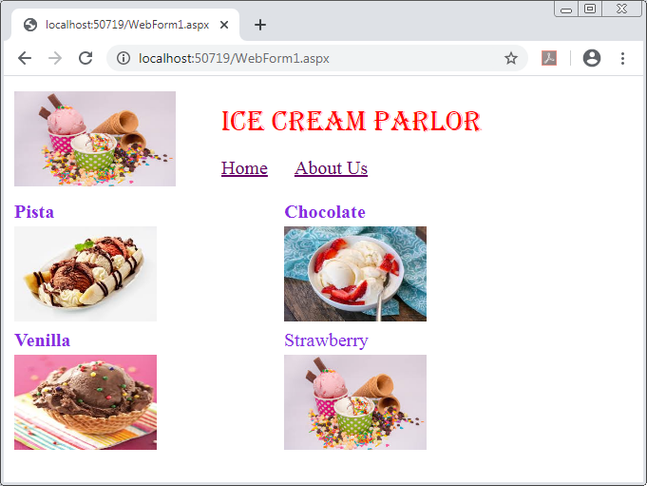

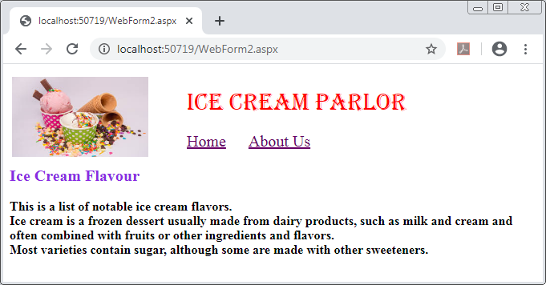

**Practical No. 10**

**Aim: Design ASP.NET Pages with various Navigation Controls**

**Default.aspx**

<%@ Page Language="C#" AutoEventWireup="true" CodeBehind="Default.aspx.cs" Inherits="WebApplication3.Default" %>

<!DOCTYPE html>

<html xmlns="http://www.w3.org/1999/xhtml">

<head runat="server">

<title></title>

<style type="text/css">

.auto-style2 {

height: 378px;

width: 831px;

}

</style>

</head>

<body>

<form id="form1" runat="server">

<div style="font-style: italic" class="auto-style2">

<asp:Label ID="Label1" runat="server" Text="Menu Control" Font-Bold="True" Font-Italic="True" ForeColor="Blue" Font-Size="20"></asp:Label>

<br />

<br />

<asp:Menu ID="Menu1" runat="server" Orientation="Horizontal" Font-Bold="True" Font-Size="10pt" ForeColor="#990000" BackColor="#FFFBD6" DynamicHorizontalOffset="2" Font-Names="Constantia" StaticSubMenuIndent="10px">

<DynamicHoverStyle BackColor="Black" ForeColor="White" />

<DynamicMenuItemStyle HorizontalPadding="5px" VerticalPadding="2px" />

<DynamicMenuStyle BackColor="Black" />

<DynamicSelectedStyle BackColor="Black" />

<Items>

<asp:MenuItem Text="Home" Value="Home" NavigateUrl="Home.aspx"></asp:MenuItem>

<asp:MenuItem Text="About Us" Value="Aboutus" NavigateUrl="Aboutus.aspx"></asp:MenuItem>

<asp:MenuItem Text="Product" Value="Product" NavigateUrl="Product.aspx"></asp:MenuItem>

<asp:MenuItem Text="Reviews" Value="Reviews" NavigateUrl="Reviews.aspx"></asp:MenuItem>

<asp:MenuItem Text="Contact No." Value="ContactNo." NavigateUrl="ContactNo.aspx"></asp:MenuItem>

</Items>

<StaticHoverStyle BackColor="Black" ForeColor="White" />

<StaticMenuItemStyle HorizontalPadding="20px" VerticalPadding="5px" />

<StaticSelectedStyle BackColor="#FFCC66" />

</asp:Menu>

<br />

<br />

<br />

<br />

<asp:Label ID="Label2" runat="server" Text="Tree View" Font-Bold="True" Font-Italic="True" ForeColor="Blue" Font-Size="20"></asp:Label>

<asp:TreeView ID="TreeView1" runat="server" ImageSet="BulletedList2" ShowExpandCollapse="False" ShowLines="True" Font-Bold="True" Font-Italic="True" Font-Size="10pt" Font-Names="Constantia">

<HoverNodeStyle Font-Underline="True" ForeColor="#5555DD" />

<Nodes>

<asp:TreeNode NavigateUrl="~/Home.aspx" Text="Home" Value="Home"></asp:TreeNode>

<asp:TreeNode NavigateUrl="~/Aboutus.aspx" Text="About Us" Value="Aboutus"></asp:TreeNode>

<asp:TreeNode NavigateUrl="~/Product.aspx" Text="Product" Value="Product"></asp:TreeNode>

<asp:TreeNode NavigateUrl="~/Reviews.aspx" Text="Reviews" Value="Reviews"></asp:TreeNode>

<asp:TreeNode NavigateUrl="~/ContactNo.aspx" Text="Contact No" Value="ContactNo."></asp:TreeNode>

</Nodes>

<NodeStyle Font-Names="Tahoma" Font-Size="10pt" ForeColor="Black" HorizontalPadding="5px" NodeSpacing="0px" VerticalPadding="0px" />

<ParentNodeStyle Font-Bold="False" />

<SelectedNodeStyle Font-Underline="True" ForeColor="#5555DD" HorizontalPadding="0px" VerticalPadding="0px" />

</asp:TreeView>

<br />

<br />

</div>

</form>

</body>

</html>

**Home.aspx**

<%@ Page Language="C#" AutoEventWireup="true" CodeBehind="Home.aspx.cs" Inherits="WebApplication3.Home" %>

<!DOCTYPE html>

<html xmlns="http://www.w3.org/1999/xhtml">

<head runat="server">

<title></title>

</head>

<body>

<form id="form1" runat="server">

<div style="height: 274px; width: 806px; font-style: italic">

<h1>Home Page</h1>

<asp:SiteMapPath ID="SiteMapPath1" runat="server"></asp:SiteMapPath>

</div>

</form>

</body>

</html>

**Aboutus.aspx**

<%@ Page Language="C#" AutoEventWireup="true" CodeBehind="Aboutus.aspx.cs" Inherits="WebApplication3.Aboutus" %>

<!DOCTYPE html>

<html xmlns="http://www.w3.org/1999/xhtml">

<head runat="server">

<title></title>

</head>

<body>

<form id="form1" runat="server">

<div style="height: 274px; width: 806px; font-style: italic">

<h1>About Us</h1>

<asp:sitemappath ID="Sitemappath1" runat="server"></asp:sitemappath>

</div>

</form>

</body>

</html>

**Product.aspx**

<%@ Page Language="C#" AutoEventWireup="true" CodeBehind="Product.aspx.cs" Inherits="WebApplication3.Product" %>

<!DOCTYPE html>

<html xmlns="http://www.w3.org/1999/xhtml">

<head runat="server">

<title></title>

</head>

<body>

<form id="form1" runat="server">

<div style="height: 274px; width: 806px; font-style: italic">

<h1>Product</h1>

<asp:sitemappath ID="Sitemappath1" runat="server"></asp:sitemappath>

</div>

</form>

</body>

</html>

**Reviews.aspx**

<%@ Page Language="C#" AutoEventWireup="true" CodeBehind="Reviews.aspx.cs" Inherits="WebApplication3.Reviews" %>

<<!DOCTYPE html>

<html xmlns="http://www.w3.org/1999/xhtml">

<head runat="server">

<title></title>

</head>

<body>

<form id="form1" runat="server">

<div style="height: 274px; width: 806px; font-style: italic">

<h1>Review</h1>

<asp:sitemappath ID="Sitemappath1" runat="server"></asp:sitemappath>

</div>

</form>

</body>

</html>

**ContactNo.aspx**

<%@ Page Language="C#" AutoEventWireup="true" CodeBehind="ContactNo.aspx.cs" Inherits="WebApplication3.ContactNo" %>

<!DOCTYPE html>

<html xmlns="http://www.w3.org/1999/xhtml">

<head runat="server">

<title></title>

</head>

<body>

<form id="form1" runat="server">

<div style="height: 274px; width: 806px; font-style: italic">

<h1>Contact No</h1>

<asp:sitemappath ID="Sitemappath1" runat="server"></asp:sitemappath>

</div>

</form>

</body>

</html>

**Web.sitemap**

<?xml version="1.0" encoding="utf-8" ?>

<siteMap xmlns="http://schemas.microsoft.com/AspNet/SiteMap-File-1.0" >

<siteMapNode url="Home.aspx" title="Home..." description="">

<siteMapNode url="Aboutus.aspx" title="About Us..." description="">

<siteMapNode url="Product.aspx" title="Product..." description="" >

<siteMapNode url="Reviews.aspx" title="Reviews...">

<siteMapNode url="ContactNo.aspx" title="Contact No...">

</siteMapNode>

</siteMapNode>

</siteMapNode>

</siteMapNode>

</siteMapNode>

</siteMap>

**Output:**

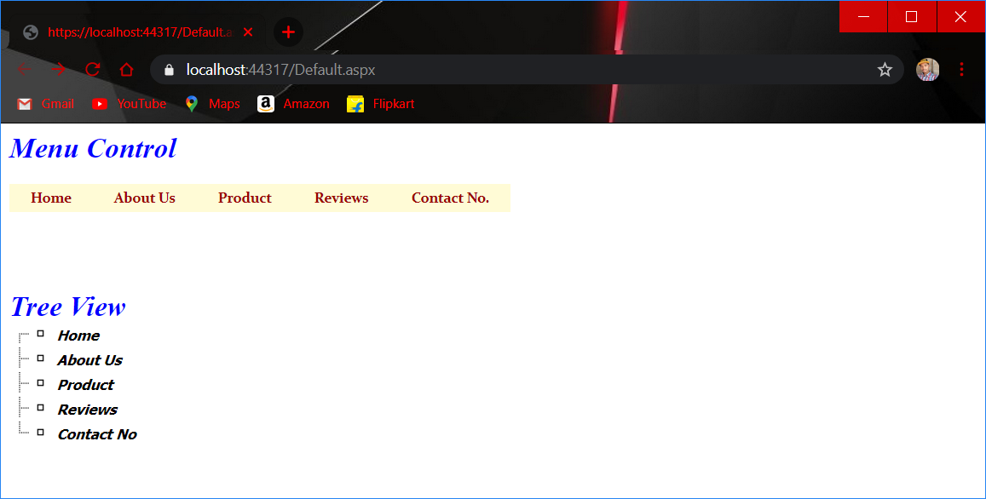

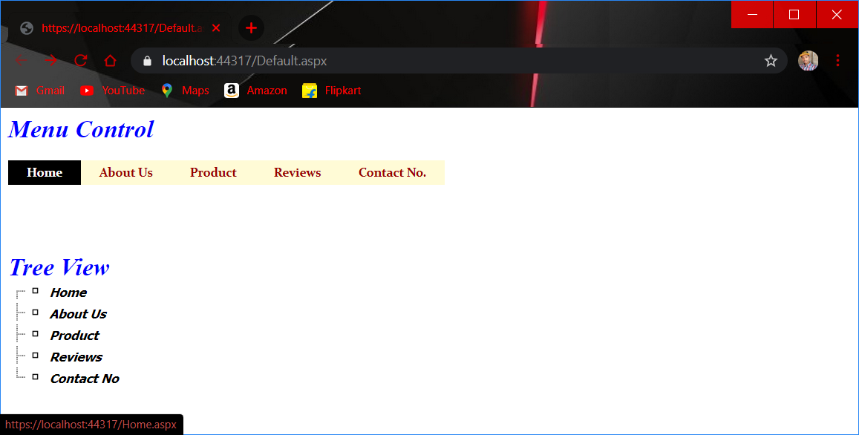

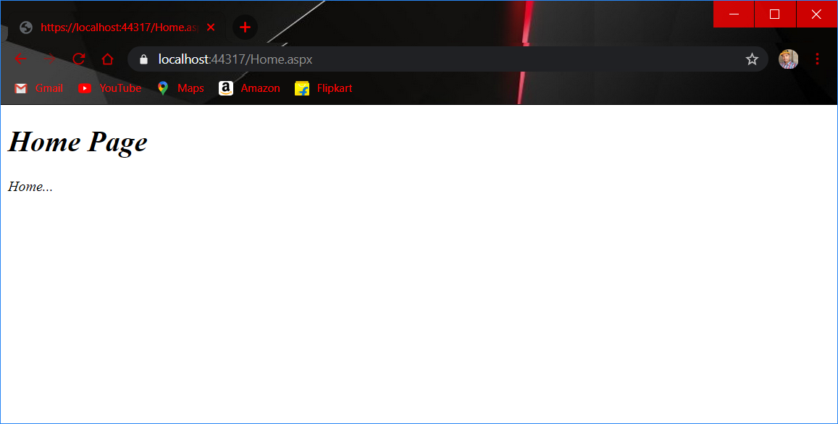

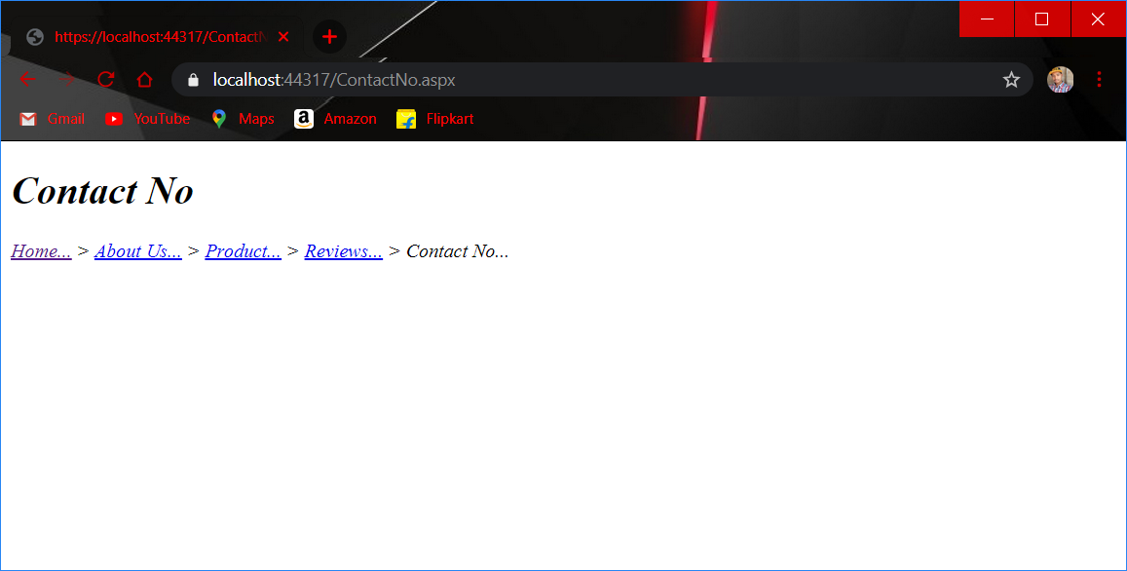

**Practical No-: 11**

**Aim:-Performing ADO.NET data access in ASP.NET for Simple Data Binding**

**1) Simple Data Binding**

**Input (WebForm1.aspx) file**

<%@ Page Language="C#" AutoEventWireup="true" CodeBehind="WebForm1.aspx.cs" Inherits="WebApplication1.WebForm1" %>

<!DOCTYPE html>

<html xmlns="http://www.w3.org/1999/xhtml">

<head runat="server"><title></title></head>

<body>

<form id="form1" runat="server">

<asp:DropDownList ID="DropDownList1" runat="server" AutoPostBack="True" DataSourceID="SqlDataSource1" DataTextField="cloth_colour" DataValueField="cloth_colour">

</asp:DropDownList>

<asp:SqlDataSource ID="SqlDataSource1" runat="server" ConnectionString="<%$ ConnectionStrings:cloth_centerConnectionString4 %>" SelectCommand="SELECT [cloth_colour] FROM [cloth_colour]"></asp:SqlDataSource>

<br /><br /><br />

<asp:DropDownList ID="DropDownList2" runat="server" AutoPostBack="True" DataSourceID="SqlDataSource2" DataTextField="cloth_type" DataValueField="cloth_type">

</asp:DropDownList>

<asp:SqlDataSource ID="SqlDataSource2" runat="server" ConnectionString="<%$ ConnectionStrings:cloth_centerConnectionString5 %>" SelectCommand="SELECT [cloth_type] FROM [cloth_type]"></asp:SqlDataSource>

<br /><br /><br /><br />

<asp:GridView ID="GridView1" runat="server" AutoGenerateColumns="False" DataSourceID="SqlDataSource3">

<Columns>

<asp:BoundField DataField="cloth_id" HeaderText="cloth_id" SortExpression="cloth_id" />

<asp:BoundField DataField="cloth_type" HeaderText="cloth_type" SortExpression="cloth_type" />

<asp:BoundField DataField="cloth_colour" HeaderText="cloth_colour" SortExpression="cloth_colour" />

<asp:BoundField DataField="cloth_price" HeaderText="cloth_price" SortExpression="cloth_price" />

</Columns>

</asp:GridView>

<asp:SqlDataSource ID="SqlDataSource3" runat="server" ConnectionString="<%$ ConnectionStrings:cloth_centerConnectionString6 %>" SelectCommand="SELECT * FROM [all_cloths] WHERE (([cloth_colour] = @cloth_colour) AND ([cloth_type] = @cloth_type))">

<SelectParameters>

<asp:ControlParameter ControlID="DropDownList1" Name="cloth_colour" PropertyName="SelectedValue" Type="String" />

<asp:ControlParameter ControlID="DropDownList2" Name="cloth_type" PropertyName="SelectedValue" Type="String" />

</SelectParameters>

</asp:SqlDataSource>

</form></body></html>

**Create a database into SQL server Manager:**

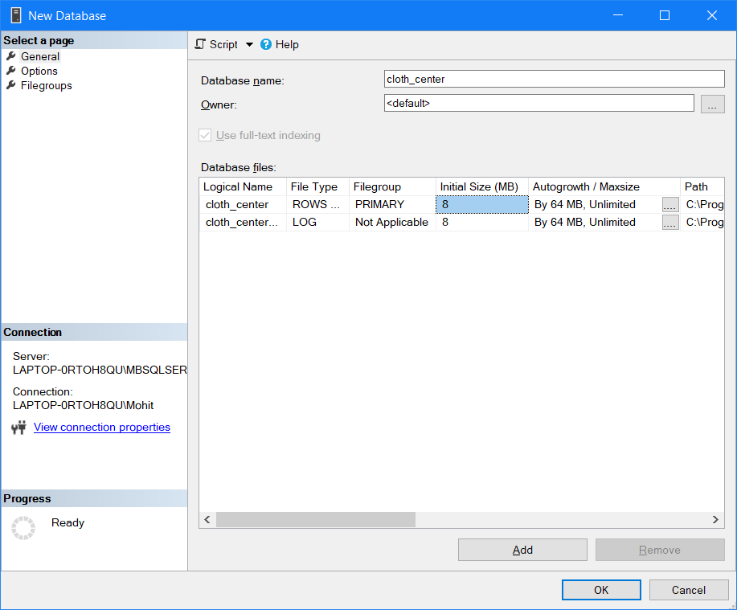

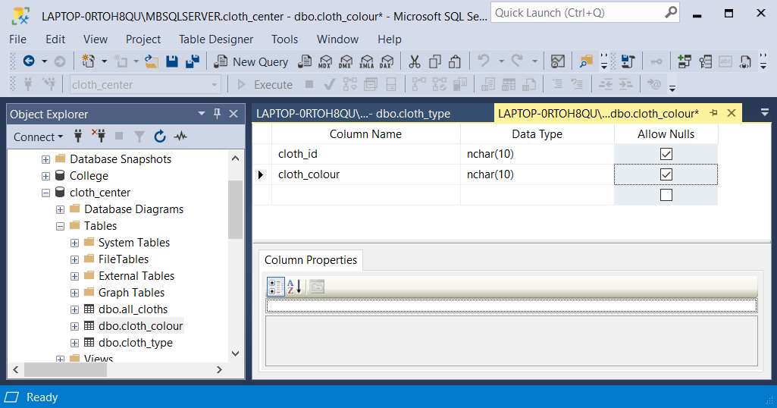

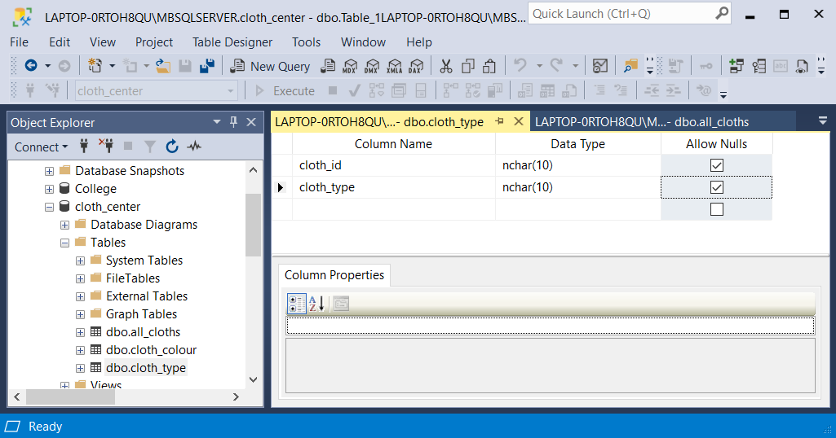

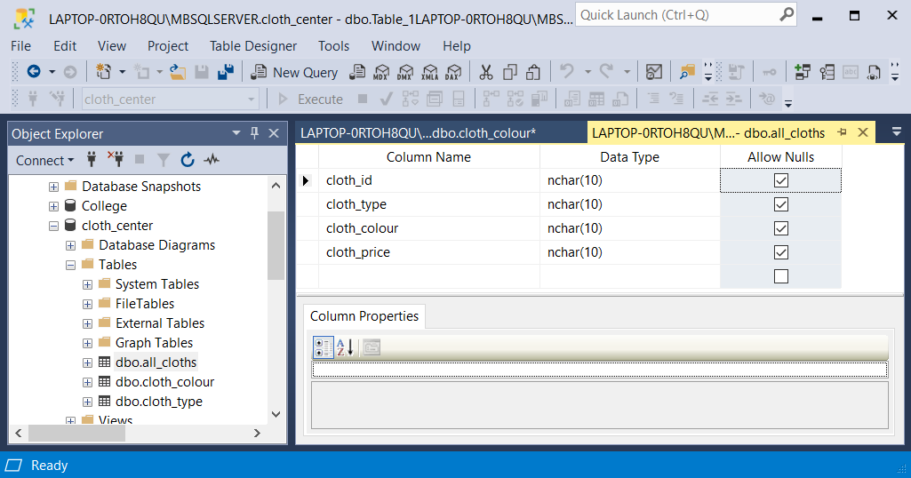

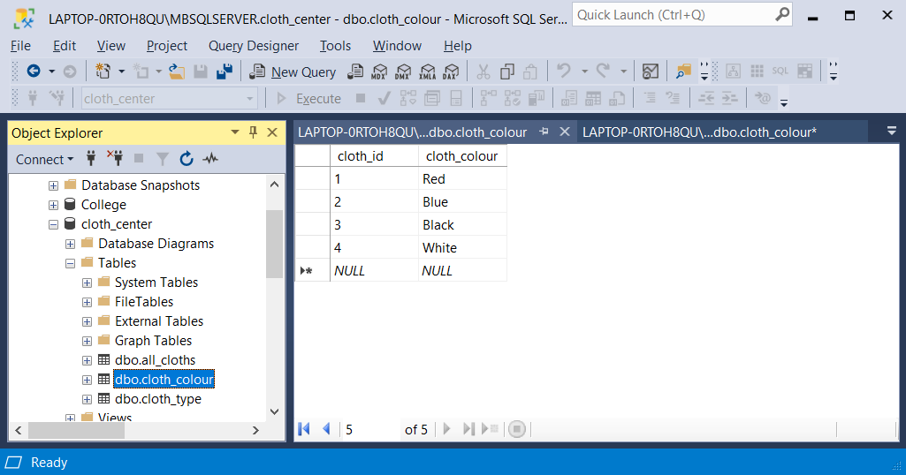

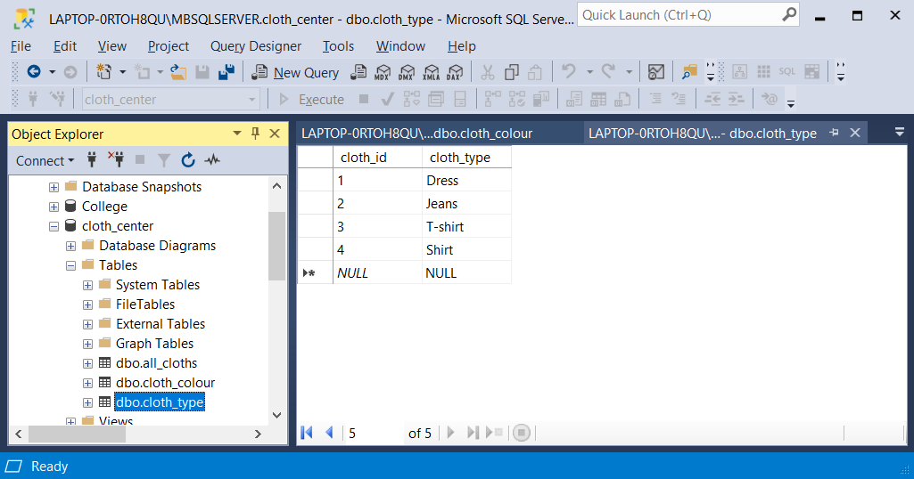

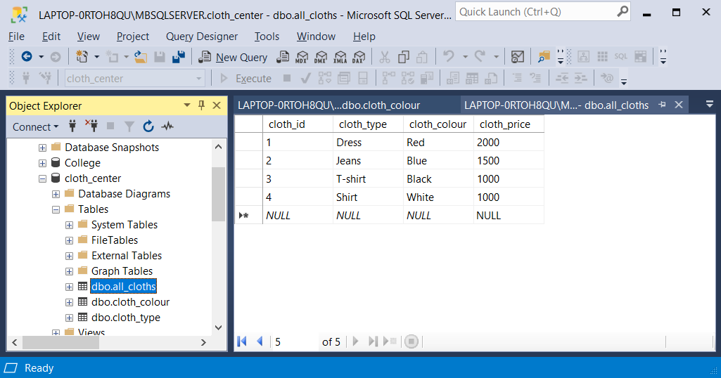

**Dropdownlist1 :**

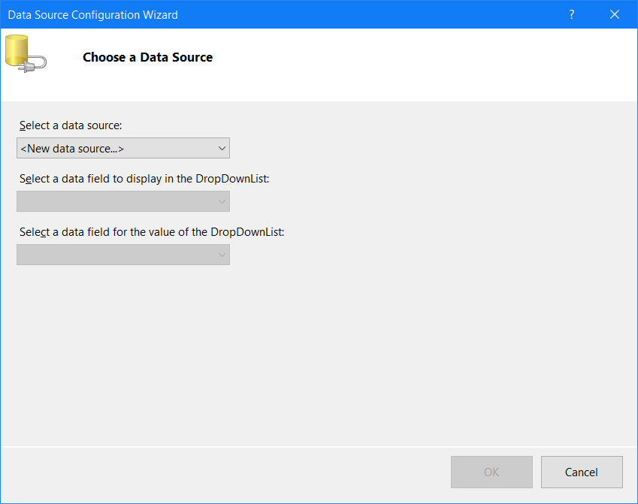

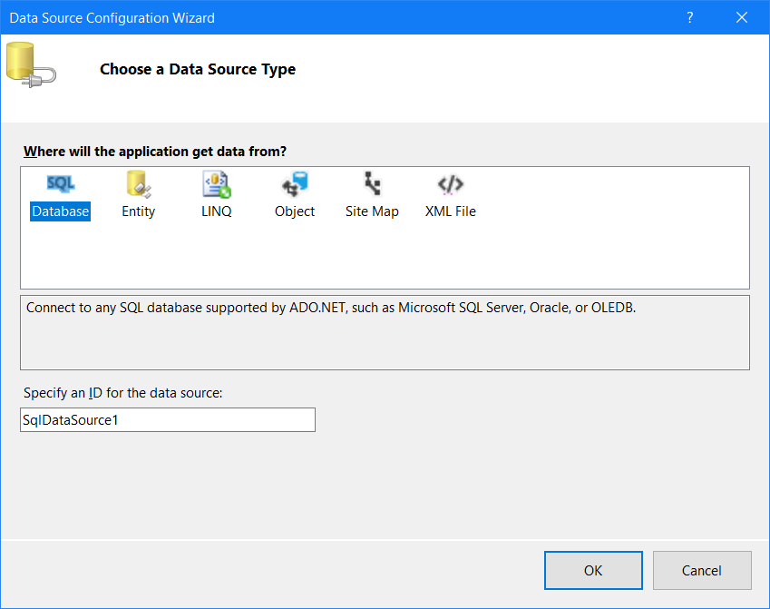

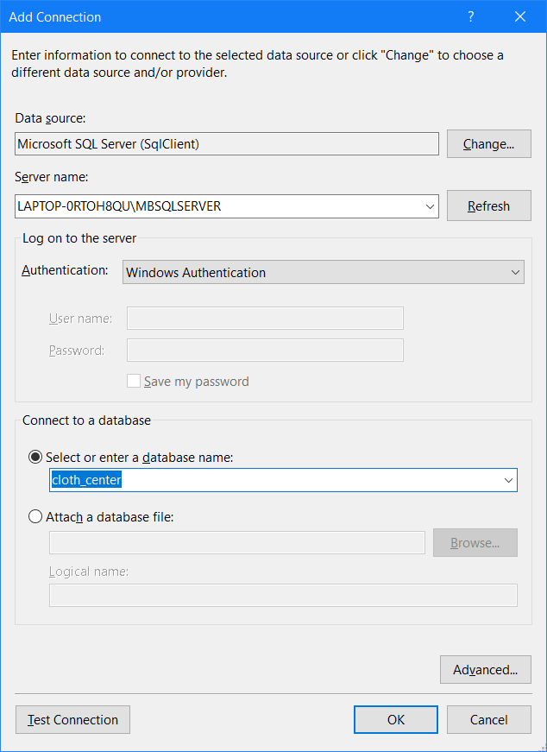

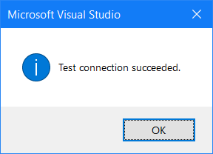

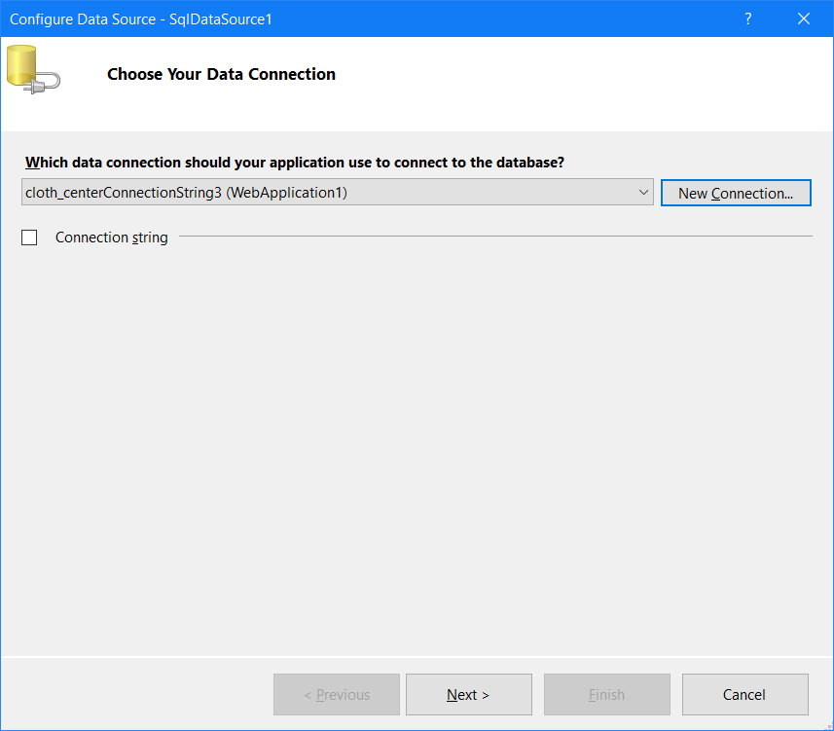

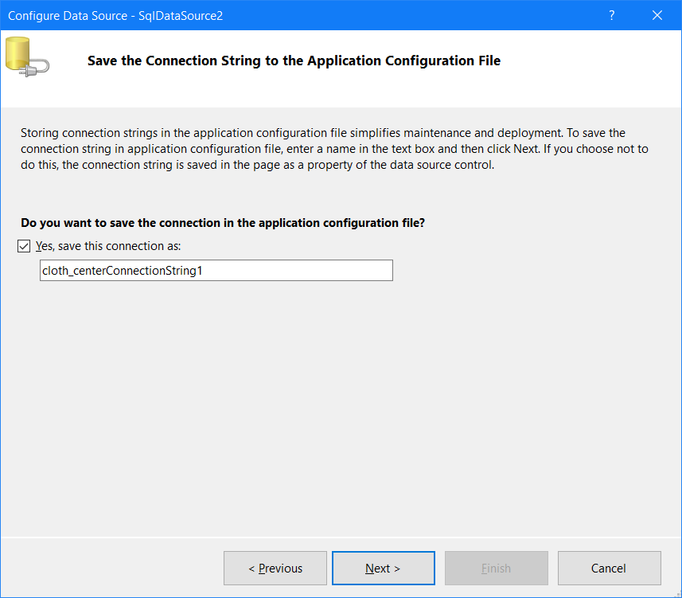

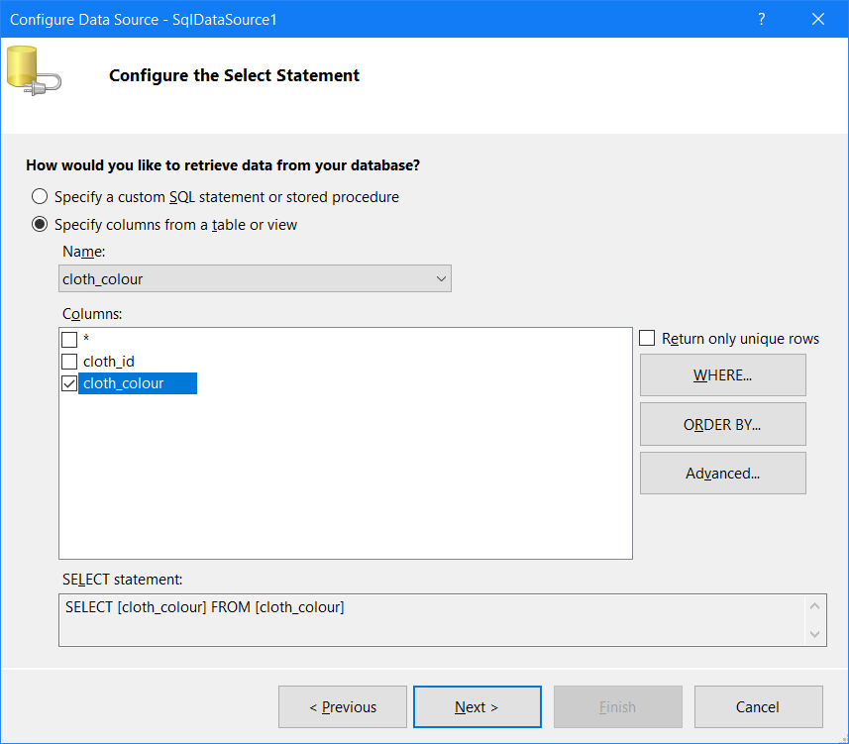

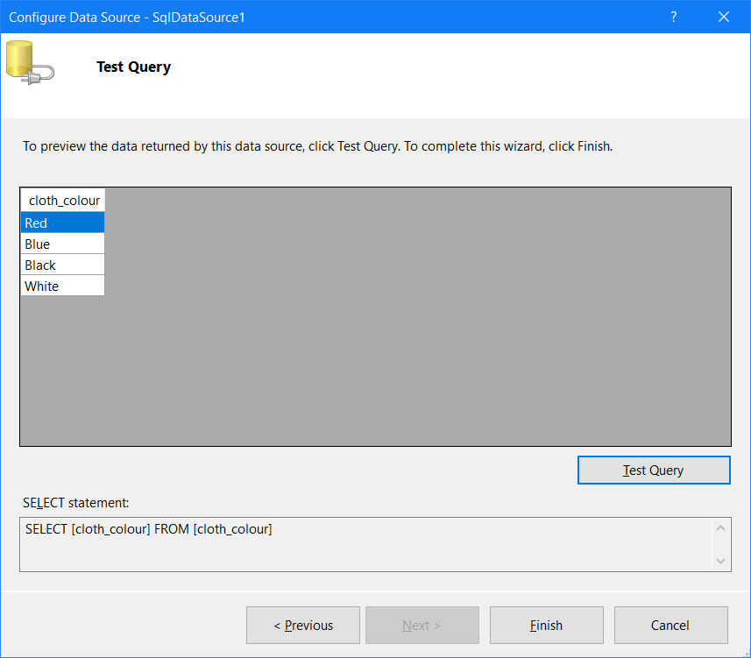

**Dropdownlist2 :**

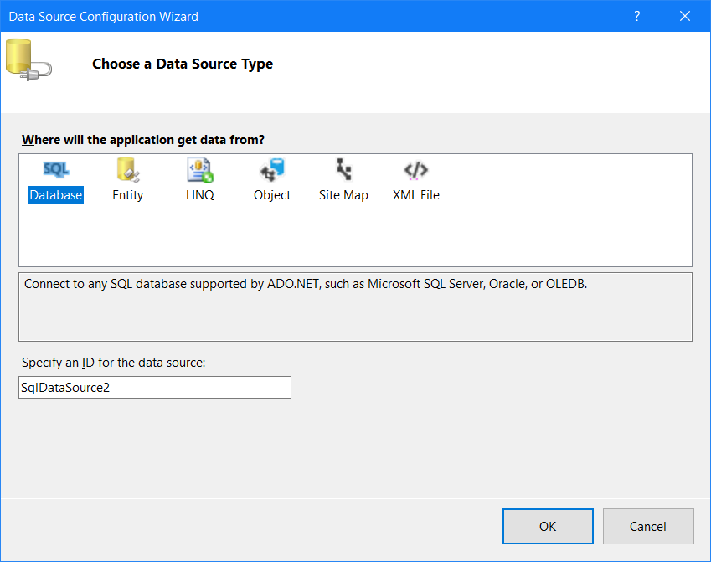







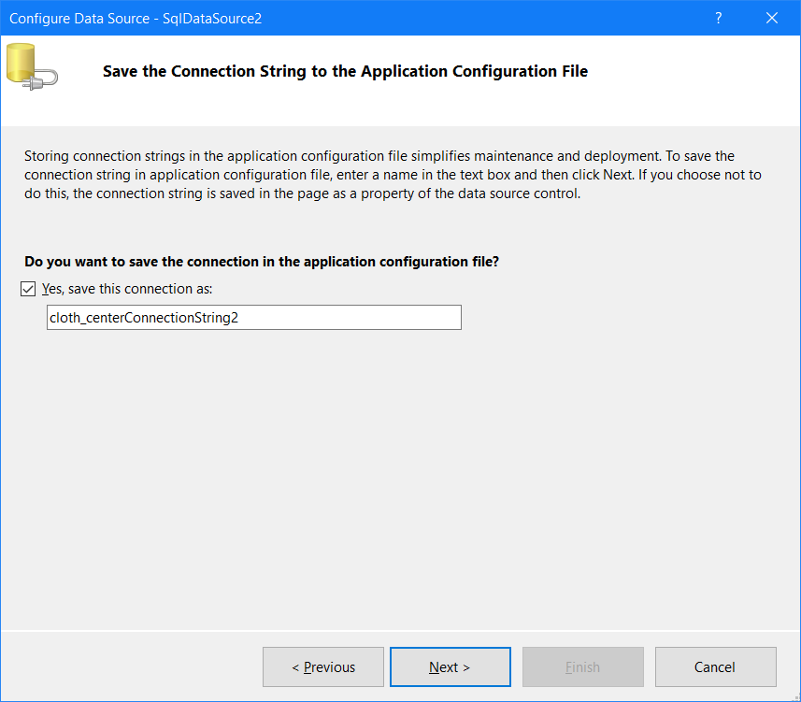 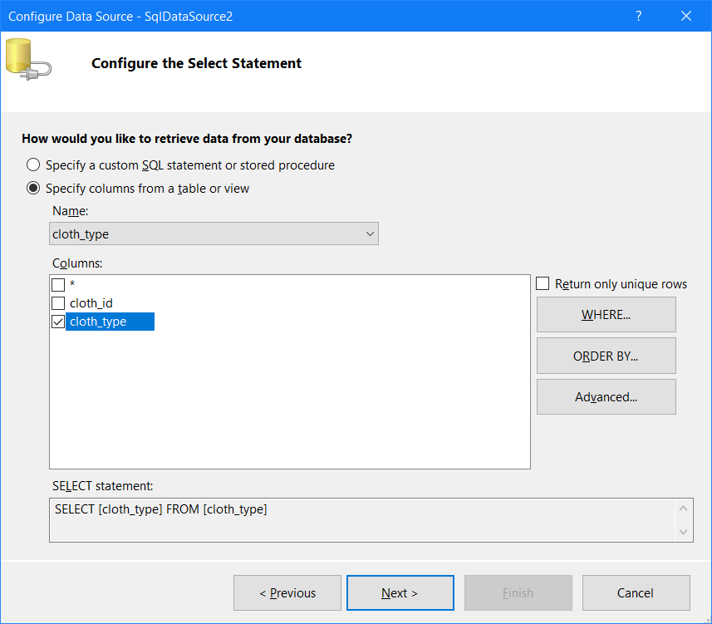 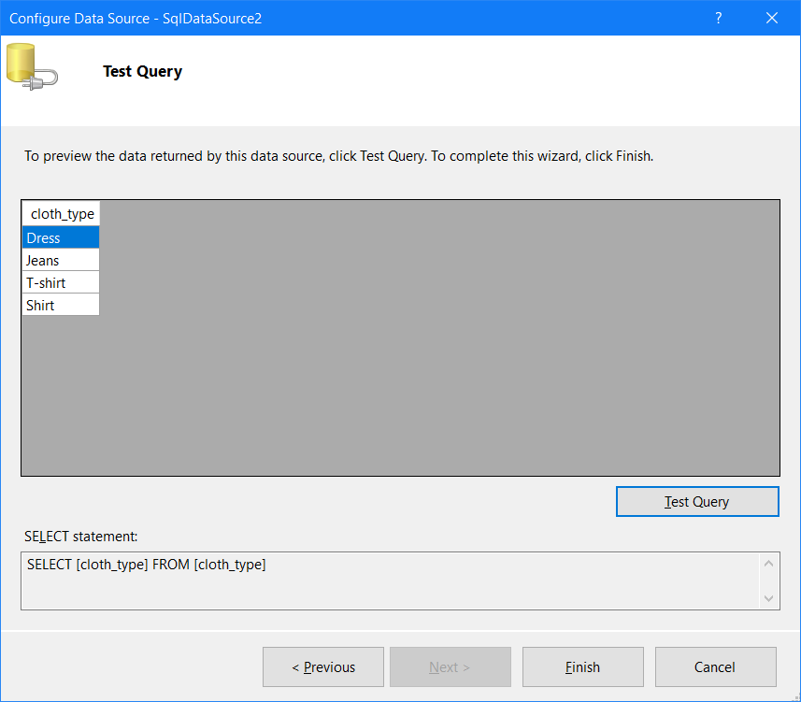

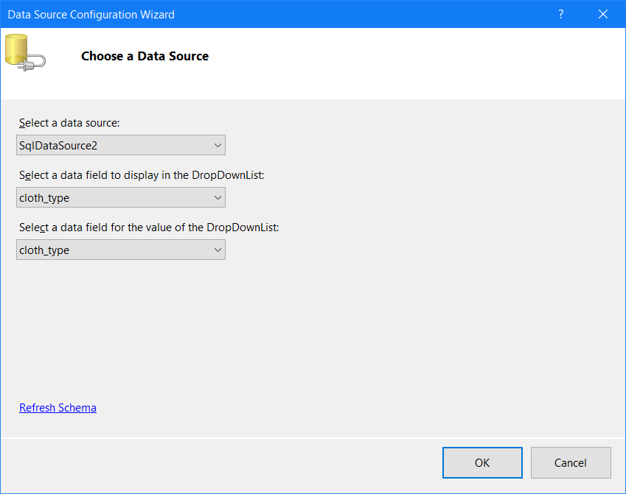

**Gridview :** 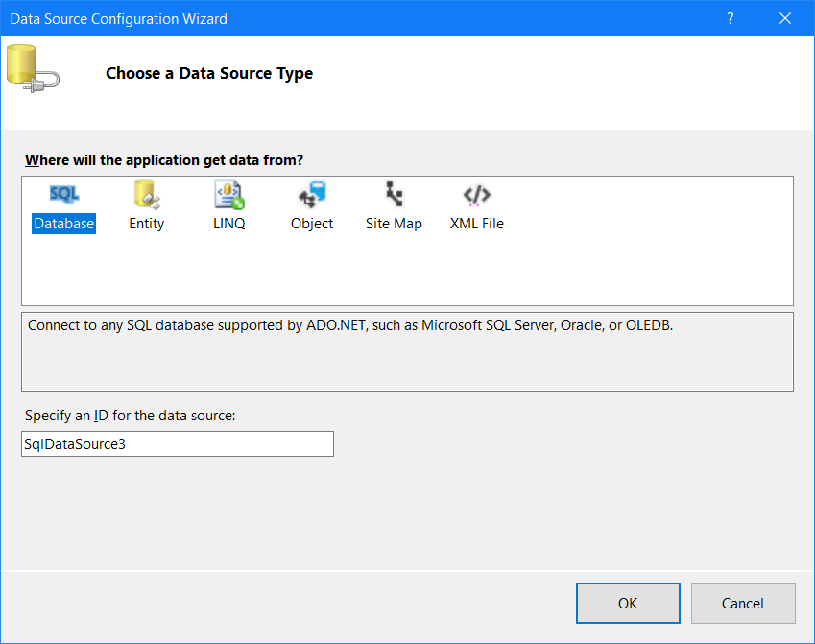







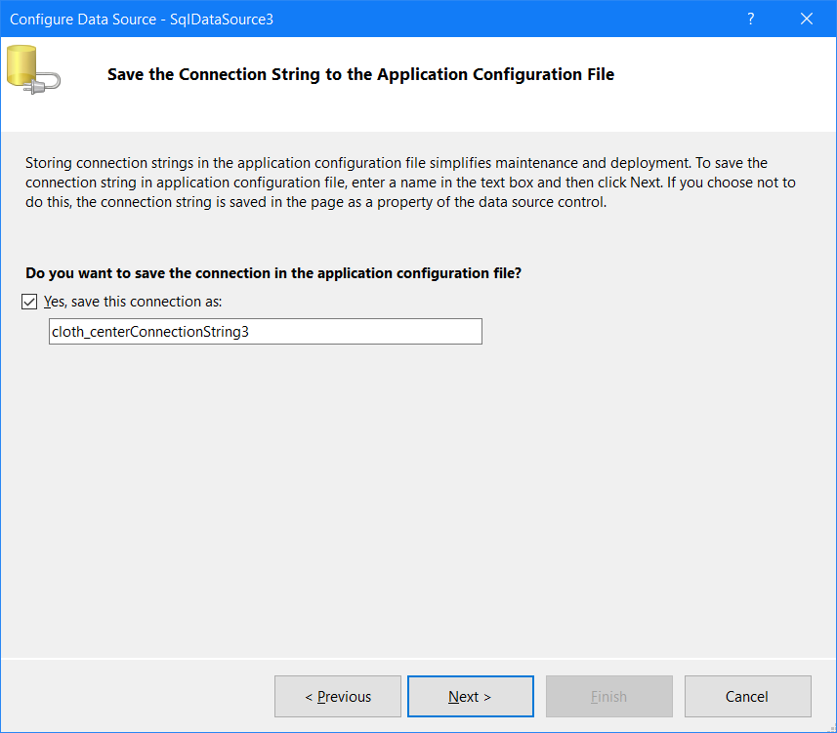 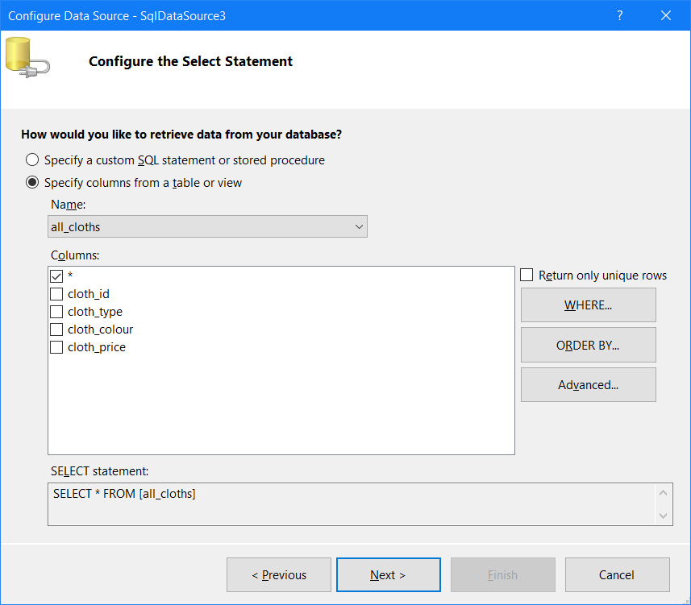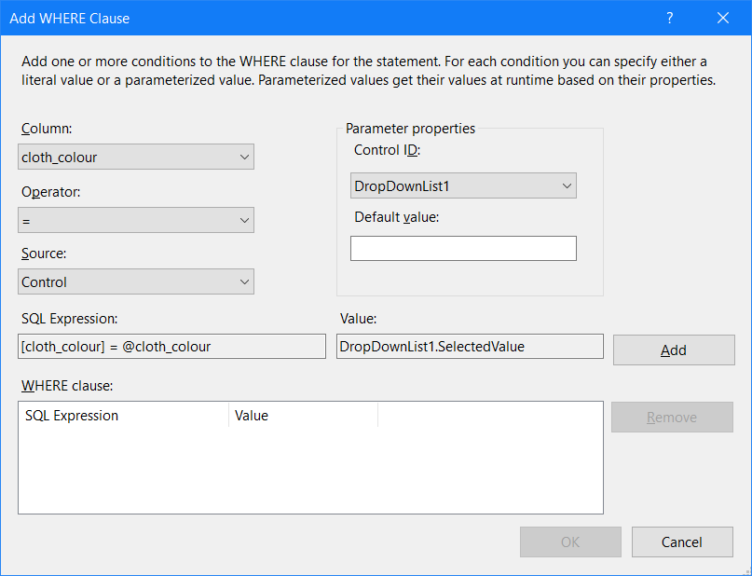 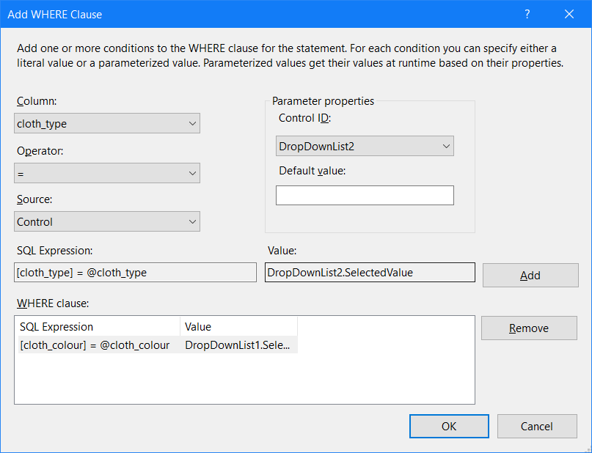 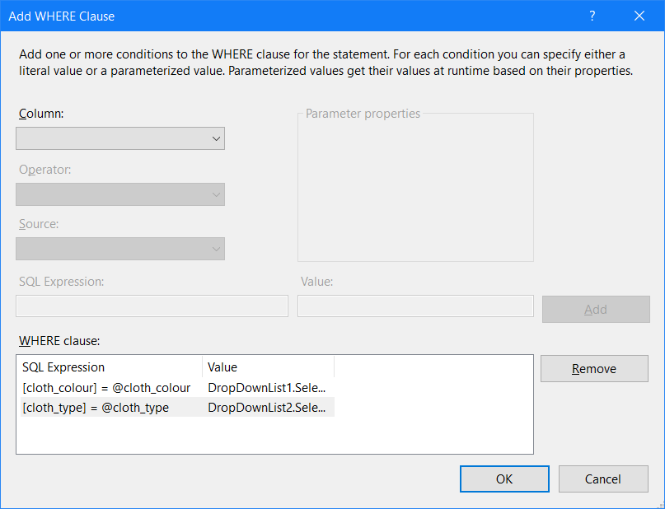 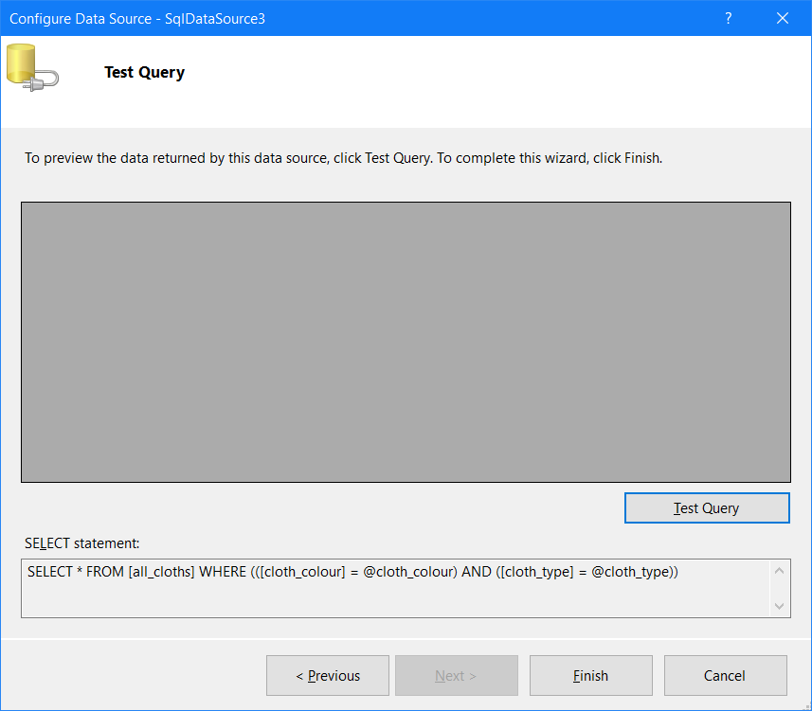 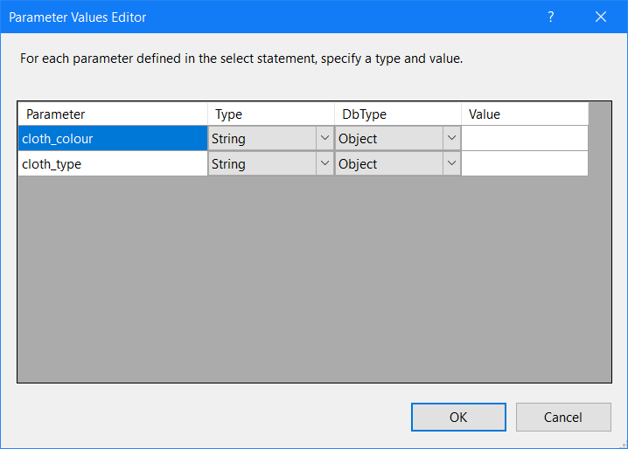 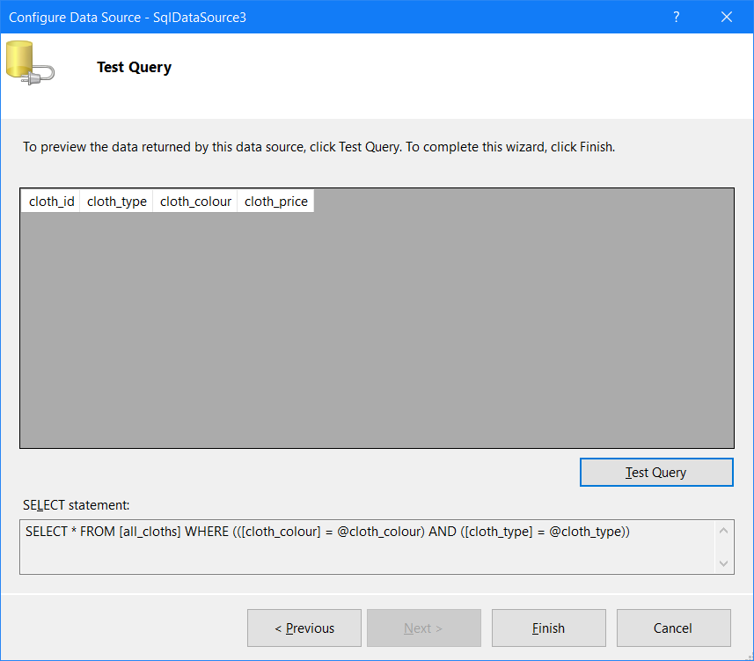

**Output :**

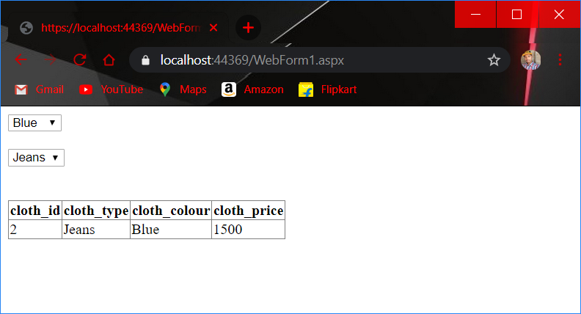

**Practical No-: 12**

**Aim:-Performing ADO.NET data access in ASP.NET for Repeated Value Data Binding**

**WebForm1.aspx file**

<%@ Page Language="C#" AutoEventWireup="true" CodeBehind="WebForm1.aspx.cs" Inherits="WebApplication24.WebForm1" %>

<!DOCTYPE html>

<html xmlns="http://www.w3.org/1999/xhtml">

<head runat="server"><title></title></head>

<body>

<form id="form1" runat="server">

<p> <b>ArrayList Binding </b></p>

<p><b> DropDownList Control:MyDropDownList</b></p>

<p>

<asp:DropDownList ID="DropDownList1" runat="server">

</asp:DropDownList>

</p>

<p><b>RadioButtonList Control:MyRadioButtonList</b></p>

<p>

<asp:RadioButtonList ID="RadioButtonList1" runat="server"></asp:RadioButtonList>

</p>

<p><b>DataList Control:MyDataList</b></p>

<p>

<asp:DataList ID="DataList1" runat="server">

<ItemTemplate><%#Container.DataItem %></ItemTemplate>

</asp:DataList>

</p>

<p><b>DataGrid Control:MyDataGrid</b></p>

<p>

<asp:GridView ID="GridView1" runat="server">

</asp:GridView>

</p></form></body></html>

**Input (WebForm1.aspx.cs) file**

using System.Collections;

using System;

using System.Collections.Generic;

using System.Linq;

using System.Web;

using System.Web.UI;

using System.Web.UI.WebControls;

namespace WebApplication24

{

public partial class WebForm1 : System.Web.UI.Page

{

protected void Page_Load(object sender, EventArgs e)

{

//Create an arrayList of values to bind to

ArrayList MyArrayList = new ArrayList();

MyArrayList.Add("Turbo C#");

MyArrayList.Add("C# Programming");

MyArrayList.Add("DOS Basic training");

MyArrayList.Add("C# Parttern with ASP.NET");

MyArrayList.Add("ADO.NET in Action");

MyArrayList.Add("Intermediate ASP.NET");

// Bind thwe control to the data

DropDownList1.DataSource = MyArrayList;

RadioButtonList1.DataSource = MyArrayList;

DataList1.DataSource = MyArrayList;

GridView1.DataSource = MyArrayList;

//Bind all controls on the page

Page.DataBind();

}

}

}

**O/P:-**

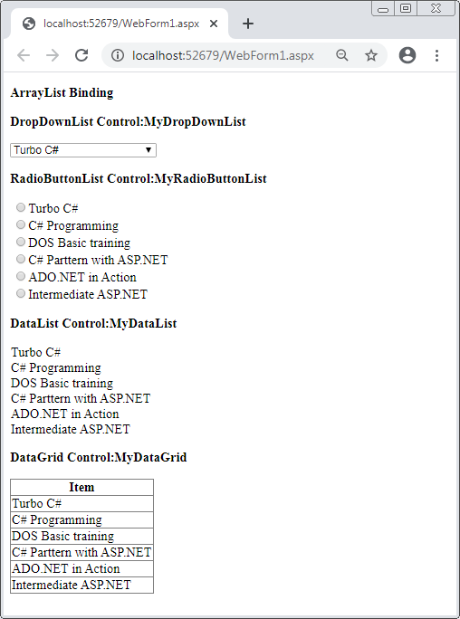

**Practical No:-13**

**Aim:-Design ASP.NET pages for performance improvement using Caching.**

**WebForm1.aspx**

<%@ Page Language="C#" AutoEventWireup="true" CodeBehind="WebForm1.aspx.cs" Inherits="WebApplication19.WebForm1" %>

<%@ OutputCache Duration="20" VaryByParam="none" %>

<!DOCTYPE html>

<html xmlns="http://www.w3.org/1999/xhtml">

<head runat="server"><title></title></head>

<body>

<form id="form1" runat="server">

<div><asp:Label ID="Label1" runat="server" Text="Label"></asp:Label>

</div></form></body></html>

**WebForm1.aspx.cs:**

using System;

using System.Collections.Generic;

using System.Linq;

using System.Web;

using System.Web.UI;

using System.Web.UI.WebControls;

namespace WebApplication19

{

public partial class WebForm1 : System.Web.UI.Page

{

protected void Page_Load(object sender, EventArgs e)

{

Label1.Text = DateTime.Now.ToString();

}

}

}

**O/P:-**

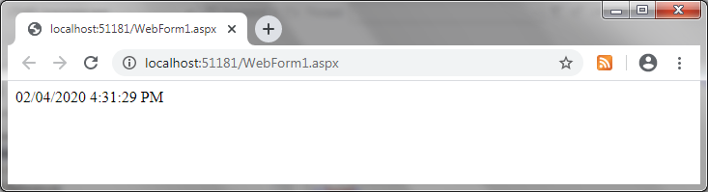

**Practical No:- 14**

**Aim:- Design ASP.NET application to query a database using LINQ.**

WebForm1.aspx

<%@ Page Language="C#" AutoEventWireup="true" CodeBehind="WebForm1.aspx.cs" Inherits="WebApplication4.WebForm1" %>

<!DOCTYPE html>

<html xmlns="http://www.w3.org/1999/xhtml">

<head runat="server"> <title></title></head>

<body>

<form id="form1" runat="server">

<div>

<strong>LINQ<br />

</strong>

<br /><br />

<asp:Label ID="Label1" runat="server" Text="Label"></asp:Label><br />

<asp:Button ID="Button1" runat="server" Height="34px" OnClick="Button1_Click" Text="Button" />

</div></form></body>

</html>

WebForm1.aspx.cs

using System;

using System.Collections.Generic;

using System.Linq;

using System.Web;

using System.Web.UI;

using System.Web.UI.WebControls;

namespace WebApplication4

{

public partial class WebForm1 : System.Web.UI.Page

{

protected void Page_Load(object sender, EventArgs e)

{

}

protected void Button1_Click(object sender, EventArgs e)

{

Label1.Text = "";

string[] authors = new string[] { "Rohini","Sonali","Ankita", "Tony", "Kshitij", "Dipak", "Onkar", "Ankur" };

var result = from author in authors where author.Contains("n") orderby author select author;

foreach (var author in result)

{

Label1.Text += author + "<br/>";

}

}

}

}

O/P:-

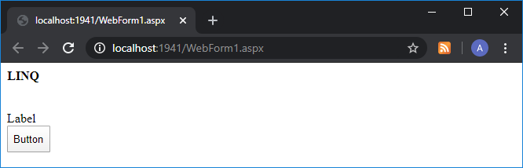

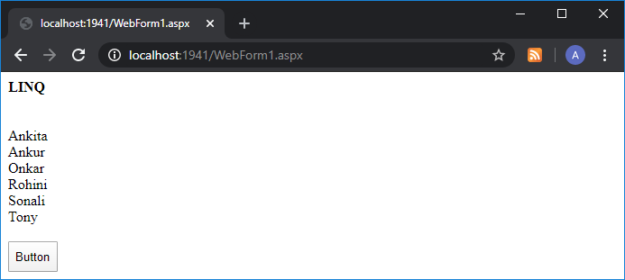

**Practical No:-15**

**Aim:- Design and use AJAX based ASP.NET pages.**

**WebForm1.aspx:**

<%@ Page Language="C#" AutoEventWireup="true" CodeBehind="WebForm1.aspx.cs" Inherits="WebApplication23.WebForm1" %>

<!DOCTYPE html>

<html xmlns="http://www.w3.org/1999/xhtml">

<head runat="server">

<title></title>

</head>

<body>

<form id="form1" runat="server">

<div>

<asp:ScriptManager ID="ScriptManager1" runat="server">

</asp:ScriptManager>

<br />

<br />

<asp:UpdatePanel ID="UpdatePanel1" runat="server">

<ContentTemplate>

<asp:Label ID="Label1" runat="server" Text="Label"></asp:Label><br />

<asp:Button ID="Button1" runat="server" Text="Partial postback" OnClick="Button1_Click" />

</ContentTemplate>

</asp:UpdatePanel>

<p> </p>

<p> out of the update panal</p>

<asp:Label ID="Label2" runat="server" Text="Label"></asp:Label><br />

<asp:Button ID="Button2" runat="server" Text="Total postback" OnClick="Button2_Click" />

<br />

<br />

<br />

</div>

</form>

</body>

</html>

**WebForm1.aspx.cs:**

using System;

using System.Collections.Generic;

using System.Linq;

using System.Web;

using System.Web.UI;

using System.Web.UI.WebControls;

namespace WebApplication23

{

public partial class WebForm1 : System.Web.UI.Page

{

protected void Page_Load(object sender, EventArgs e)

{

}

protected void Button1_Click(object sender, EventArgs e)

{

String t1 = DateTime.Now.ToLongTimeString();

Label1.Text = "Showing time from panel control " + t1;

}

protected void Button2_Click(object sender, EventArgs e)

{

String t1 = DateTime.Now.ToLongTimeString();

Label2.Text = "Showing time outside panel " + t1;

}

}

}

**O/P:-**

